**Institute of Information Technology**

**Noakhali Science and Technology University**



**Internship Report**

**Course Code - SE 4100**

**Course Title - Internship**

**Submitted By**

***Md Mynuddin***

**ASH1825007M**

**Session: 2017-18**

**Performed at**

***Genuity Systems Ltd***



Institute of Information Technology, Noakhali Science and Technology University

**Bachelor of Science in Software Engineering**

**Course Code: SE 4100**



**Internship Report**

**Submitted by**

*Md Mynuddin*

ASH1825007M

**Submitted to**

*Md. Iftekharul Alam Efat*

Chairman, Internship Placement Office

Assistant Professor, Institute of Information Technology (IIT)

Noakhali Science and Technology University

**Performed at**

GenuitySystems Ltd.

Plot-08, Road-4, Block-A, Section-11, Mirpur, Dhaka-1216, Bangladesh



**Internship Attended:** March 15, 2022 – September 20, 2022

**Date of Submission: October 10, 2022**

LETTER OF TRANSMITTAL

**October 10, 2022**

**The** **Chairman**

Internship Placement Office

Institute of Information Technology (IIT)

Noakhali Science and Technology University

Subject: **Letter of Transmittal**

**Dear Sir,**

This is a pleasure to submit the “Internship Report” as per Internship Program requirement for the course SE 4100 Internship.

This report contains gory details of my activities during the Internship period. I have been working as an intern at Genuity Systems Ltd. I was supervised by two individual Software Engineers of Genuity Systems Ltd, Md Nafees Mahbub and Emrul Hasan Zawad. I hope this report fulfils the requirements of Internship Program.

I am requesting to accept and consider this report.

Yours sincerely

|  |
| --- |
| **Md Mynuddin**  ASH1825007M  Session: 2017-18  BSc. in Software Engineering Program  Institute of Information Technology (IIT)  Noakhali Science and Technology University |

DECLARATION

**TO WHOM IT MAY CONCERN**

I, **Md Mynuddin**, bearing ID: ASH1825007M, BSc. in Software Engineering Program, hereby declare that the presented “Internship Report” is uniquely prepared by me after completion of six months’ work in **Genuity Systems Ltd**.

My original work is submitted to Institute of Information Technology (IIT), Noakhali Science and Technology University, and no part of the report has been submitted for any other degree, or fellowship & the work has not been published in any journal or magazine.

|  |
| --- |
| **Md Mynuddin**  ASH1825007M  Session: 2017-18  BSc. in Software Engineering Program  Institute of Information Technology (IIT)  Noakhali Science and Technology University |

LETTER OF ENDORSEMENT

**TO WHOM IT MAY CONCERN**

This is to certify that; **Md Mynuddin** was an intern at Brain Station-23 Limited. During this period, I was one of his supervisors.

I hereby endorse that I have gone through the whole report. The contents of this report are true and not confidential to the company. The projects, training assignments mentioned in this report had successful participation of Md Mynuddin.

I wish him all the very best for his future life.

|  |  |  |
| --- | --- | --- |
| **Md. Nafees Mahbub**  Project Manger  Genuity Systems Ltd. |  | **Mr. Ziaur Rahman**  CTO  Genuity Systems Ltd. |

CERTIFICATE OF APPROVAL

This Internship report submitted by **Md Mynuddin, ID No: *ASH1825007M*** to the Chairman of Internship Placement Office, Institute of Information Technology (IIT), Noakhali Science and Technology University has been accepted as satisfactory for the partial fulfillment of the requirements for the degree of Bachelor of Science in Software Engineering and approved as to its style and contents. The presentation has been held on October, 2022.

**Internship Examination Committee:**

|  |
| --- |
| **Md. Iftekharul Alam Efat**, Chairman  Assistant Professor  Institute of Information Technology (IIT)  Noakhali Science and Technology University |
|  |
| **Dipok Chandra Das**, Committee Member  Assistant Professor  Institute of Information Technology (IIT)  Noakhali Science and Technology University |
|  |
| **Md. Eusha Kadir**, Committee Member  Lecturer  Institute of Information Technology (IIT)  Noakhali Science and Technology University |
|  |
| **Md. Hasan Imam**, Committee Member  Lecturer  Institute of Information Technology (IIT)  Noakhali Science and Technology University |

DEDICATION

TABLE OF CONTENTS

|  |  |  |  |
| --- | --- | --- | --- |
| Letter of Transmittal | | | I |
| Declaration | | | II |
| Letter of Endorsement | | | III |
| Certificate of Approval | | | IV |
| Dedication | | | V |
| Table of Contents | | | VI |
| List of Figures | | | VIII |
| List of Tables | | | IX |
| Offer Letter | | | X |
| Acknowledgement | | | XI |
| Preface | | | XII |
| Executive Summary | | | XIII |
|  | | |  |
| **Chapter One** | | |  |
| **Introduction** | | | 1 |
| 1.1 |  | | 1 |
| 1.2 |  | | 2 |
|  |  | |  |
| **Chapter Two** | | |  |
| **XXXXXXXX** | | | 1 |
| 2.1 |  | |  |
| 2.2 |  | |  |
| 2.2.1 | |  |  |
| 2.2.2 | |  |  |
| 2.3 |  | |  |

ACKNOWLEDGEMENT

I would like to express my deepest gratitude to Iftekharul Alam Efat, Assistant Professor, Intern Program Chair, Institute of Information Technology, Noakhali Science and Technology University for his kind support and inspiration which has immensely strengthened my confidence during my internship program.

I owe my profound sense of gratitude to Nafees Mahbub, Software Engineer, Genuity Systems Ltd. for his kind help and cooperation during my stay at Genuity Systems Ltd. He himself managed all the things that I asked for and always provided the solutions to the problem that I faced during the completion of my projects. Without his advice, I might have sprawled and the projects might have ended in failure.

I am also very much grateful to my team members Emrul Hasan Zawad and Rifat Hasan for their great support of the project respectively. Their guidance has led me this far which I can never forget.

PREFACE

A life-changing and educational experience, my internship at Genuity Systems Ltd. gave me the chance to connect the dots between academic theory and real-world software engineering implementations. This introduction seeks to provide a thorough account of my experience as an intern, the importance of the tasks completed, and the priceless assistance I got from mentors and coworkers during this trip.

This internship report's main goal is to give an in-depth overview of my time at Genuity Systems Ltd., where I had the opportunity to work on cutting-edge projects. The facial recognition system was one such project that gave me the opportunity to fully immerse myself in the difficulties of software development. Throughout the internship, I faced a variety of difficulties, each of which offered a special chance to learn. As I overcame these challenges, I experienced enormous personal and professional progress.

I want to express my sincere appreciation to Iftekharul Alam Efat, assistant professor and director of the internship program at Noakhali Science and Technology University's Institute of Information Technology, whose consistent advice and mentoring helped to shape my experience as an intern. His words of support and enlightening criticism gave me the assurance I needed to pursue things with tenacity and persistence.

For his kind support and knowledge throughout my internship, Nafees Mahbub, a software engineer at Genuity Systems Ltd., has earned my gratitude as well. His continuous support and quick responses to problems really aided in my projects' successful completion.I also want to express my gratitude to my excellent teammates Emrul Hasan Zawad and Rifat Hasan, whose cooperation and insightful comments boosted my learning process. Together, we used our own and combined skills to effectively overcome challenges and complete project milestones.

EXECUTIVE SUMMARY

This report is a detailed overview of my internship journey at Genuity Systems Ltd. During my Internship, I have learned a lot about Communication with Team Members, Machine Learning, Neural Networks, Deep Learning, Computer Vision, and its different applications. I have known about the workflow of the company along with the functions the Software department performs. I have learned to work in a corporate space which not only enriched me professionally but also helped me grow personally as well. My contribution was appreciated by my supervisor and other members of the department. The career path I would be selecting for myself is quite influenced by my internship as I have had a great opportunity to practically see how to solve real-life problems. However, this report has been written in a short time. I have tried my level best to make it meaningful by reflecting on my work at Genuity Systems Ltd. Also, I have summarized my overall experience, with my learning and challenges faced as an intern.

**Table of Contents**

**-------------------------------------------------------**

**Letter of Transmittal**

**Letter of indorsement**

**Acknowledgement**

**Executive Summary**

**List of Figure**

Chapter 1: Introduction IX

1.1. Introduction IX

1.2. Objective X

1.3. Methodology XI

1.4. Scope XII

Chapter 2: Company Profile XIII

2.1. Company Name XIII

2.2. Registered Addressed XIV

2.3. Company Overview XIV

2.4. Mission and Vision XIV

2.6. Products XVI

2.6.1. gPlex Smart IVR XVI

Figure 2: gPlex® - Smart IVR XVII

2.6.1.1 Smart IVR Features of gPlex® XVII

2.6.2. Call Blaster XVIII

2.6.2.1 Reach Millions in Hours XIX

Figure 4: gPlex® Call Blaster Solution XIX

2.6.2.2 Benefits of gPlex® Call Blaster XX

2.6.2.3. How gPlex Call Blaster do for your Business promotion? XX

2.6.3. Mobile Banking Apps XXI

2.6.3.1. gPlex® Mobile Banking App Features XXII

2.6.4. Advanced IT Training XXII

2.6.4.1. Visit a professional and act like one! XXII

Figure 7: Contact Center Solution XXIV

2.7.1.1. gPlex® - Enhancing Customer Experience! XXIV

2.7.1.2. gPlex® Contact Center Feature XXIV

2.7.2. Smart PBX Solution XXV

2.7.2.1. Smart Business Phone Solution XXV

2.7.3. Mobile Application XXVI

2.7.3.1. Types of Application: XXVII

2.8. BPO Services XXVIII

2.8.1. Call Center Services XXVIII

2.8.1.1. Contact Center Service XXIX

2.8.2. Why Select Genuity BPO as a Partner for Call Center Outsourcing Services? XXIX

2.9. Company Hierarchy XXX

2.10. Office Culture and Environment XXXI

2.10.1. Overview XXXI

One of an organization's most crucial resources is its human capital. An organization's effectiveness and success are dependent on its employees. So it's crucial to offer both a professional setting and a healthy, welcoming environment. Genuity thinks that while on the job, employees should be emotionally and physically healthy and totally love what they do. Therefore, Genuity offers all the amenities required for staff members' rest while doing their creative duties. XXXI

2.10.2. Friendly Working Environment XXXI

2.11.3. People XXXI

2.11.4. Beware of the Meeting XXXI

2.11.5. Self Responsibility XXXII

2.11.6 Keep the workplace Comfortable XXXII

2.11.7. Being Humble XXXII

2.11.8. An honest approach to business and trust in each other XXXIII

2.11.9. Dress Code XXXIII

2.11.10. Special Day Celebration XXXIII

2.11. Office Schedule XLV

2.12. Facilities for Employees XLV

2.12.1. Domestic Environment XLVI

2.12.2. Lunch and snacks XLVI

2.12.3. Comfortable Sitting Arrangement XLVI

2.12.4 Dinning and Prayer Room XLVI

2.12.5. Games XLVI

Chapter 3: Internship Details XLVII

3.1 Joining Letter XLVIII

3.2. Assigned Team LII

3.3. First day at office LII

3.4. Technical Skill I learn LIII

3.4.1. Python LIII

3.4.2. Statistics LIV

3.4.3. Data Visualization LV

3.4.4 Machine Learning LV

3.4.4.1 Data Preprocessing LV

3.4.4.2 Supervised Machine learning LV

3.4.4.3 Unsupervised Machine Learning LVI

3.4.5. Audio signal processing for machine learning LX

3.4.6. Bash Script LXI

3.4.7. Neural Networks LXI

3.4.8. OpenCV LXII

3.5. Assigned Project LXIV

3.5.1 Face Recognition LXIV

3.5.1.1 Project Screen Shoot LXIV

3.5.1.2 Tools and Technology I used LXVII

Chapter 4: Self Assessment LXVIII

4.3. Overall Progress LXXIII

Chapter 5: Conclusion LXXIV

Chapter 6: References LXXVI

**List of Figures**

Figure 1: Valued Clients ------------------------------------------------------------------------------------ 14

Figure 2: gPlex® - Smart IVR ----------------------------------------------------------------------------- 15

Figure 3: Call Blaster ---------------------------------------------------------------------------------------- 16

Figure 4: gPlex® Call Blaster Solution ------------------------------------------------------------------ 17

Figure 5: Mobile Banking Apps----------------------------------------------------------------------------- 19

Figure 6: Genuity Training------------------------------------------------------------------------------------ 21

Figure 7: Contact Center Solution-------------------------------------------------------------------------- 22

Figure 8: Smart Business Phone Solution---------------------------------------------------------------- 24

Figure 9: Call Center Services ------------------------------------------------------------------------------ 25

Figure 10: Company Hierarchy------------------------------------------------------------------------------ 28

Figure 11: Birthday Celebration of Abdullah Vai (Middle)--------------------------------------------- 31

Figure 12: Eid celebration------------------------------------------------------------------------------------- 32

Figure 13: Genuity 19th anniversary celebration------------------------------------------------------- 33

Figure 14: Farewell of an employee----------------------------------------------------------------------- 34

Figure 15: Pohela Boishakh Celebration ----------------------------------------------------------------- 35

Figure 16: Blessing us to be married in pohela boishakh celebration ----------------------------- 36

Figure 17: Food provided from the office in Pohela Boishakh Celebration ---------------------- 37

Figure 18: Machine Learning Team in Pohela Boishakh---------------------------------------------- 38

Figure 19: Iftar Party------------------------------------------------------------------------------------------- 39

Figure 20: Journey Begins with IFIC Bank--------------------------------------------------------------- 40

Figure 21: Table Tennis Championship------------------------------------------------------------------- 41

Figure 22: Annual Picnic------------------------------------------------------------------------------------- 42

Figure 23,24,25: Joining Letter---------------------------------------------------------------------------- 45

Figure 26: Office camera for face recognition---------------------------------------------------------- 60

Figure 27: Face recognition for single face------------------------------------------------------------- 61

Figure 28: Face recognition for multi-face-------------------------------------------------------------- 61

# **Chapter 1: Introduction**

## 

## **1.1. Introduction**

The definition of an internship is "any official or formal program to give practical experience for novices in an occupation or profession." The integration of academic theory and knowledge with real-world application and abilities is the most crucial aspect of internships. Students get the chance to work at an IT company for a certain, constrained amount of time to put their knowledge to use and become familiar with industry procedures. It gives students a chance to work in the field related to their studies for a set length of time. The experience earned via this internship program is significant because it enables students to see how their studies are put to use in the real world, and because it looks great on a candidate's resume as job experience. Before making long-term commitments, the internship gives students the chance to gauge their interest in a certain vocation.

I was fortunate enough to have a full semester to complete my internship at the Institute of Information Technology (IIT) of Noakhali Science and Technology University, giving me the chance to obtain practical experience. Genuity Systems Ltd. assigned me there to do my internship. On March 10, 2022, I started working as an intern with Genuity Systems Ltd. Actually, I've chosen the Data Science area because I enjoy writing Python code. I thus intended to finish my internship in this area to evaluate solutions to real-world issues. And in the seventh semester, IIT provides its students the wonderful option to participate in an internship as part of their bachelor's degree program, and I had the chance.

I received my projected assignment to the Genuity Systems ltd. Dhaka Office's "Machine Learning Team" software division. The expectations were high, but as my internship is almost over, I have to confess that it was a truly amazing experience. The road wasn't easy because I had to deal with a lot of challenges and cutting-edge technologies. But after overcoming each obstacle, I realized I had untapped potential. I consider the knowledge I've acquired to be precious. In addition, now that my internship program is finished, I feel quite confident in my ability to launch a career as a machine learning engineer.

## 

## **1.2. Objective**

The main objective of the internship is to gain a thorough understanding of professional relationships and to interact with people in the workplace. The primary objective of this document is to provide a basic overview of the internship program at Genuity Systems Ltd.This is a brief summary of my six-month internship, which was a requirement for the BSSE program. At the start of the internship, I set out to accomplish the following learning objectives:

* Gain experience
* Identify career goals
* Strengthen a resume
* Attain BSSE program credits
* Experience different work environments
* Develop new skill
* Job opportunities
* Networking
* Observe and learn ethics at work
* Leadership
* Taste the real-world problem to solve

## **1.3. Methodology**

The overall report reflects my valuable experience gained during my internship at Genuity Systems Ltd. It is a comprehensive account of the tasks, projects, and insights I encountered while working at the company. The information presented in this report is derived from my direct involvement and observations during the internship period.The data used to compile this report includes both primary and secondary sources.

* **Primary Data**
* Direct observation during the internship period
* Interaction with employees
* Team meeting
* **Secondary Data**
* Genuity Systems Ltd. website
* Genuity Systems Ltd. Linkedin profile
* Internet

## **1.4. Scope**

Every student needs internship experience to put their classroom learning into practice and gain real-world experience from any organization. This internship experience will be useful for my future career. This report was created only for academic purposes and satisfies the internship affiliation requirement. Here, I go into more detail about my entire experience from the Genuity Systems Ltd. internship program. I made an effort to outline Genuity Systems Ltd.'s corporate structure and services. This study also includes information on the structure of team management and the method of working in a team. It also discusses how I adjust to the workplace. It primarily focuses on the actual projects I worked on and the many tools and technologies I employed. The mission and vision of Genuity Systems Ltd., management, partners, clients, company culture, technology, development methodology, my role and actions with the team, etc. were also shown and documented. I worked on this report with Mr. Iftekharul Alam Efat, an assistant professor at IIT, NSTU, as my supervisor.

# **Chapter 2: Company Profile**

## **2.1. Company Name**

Genuity Systems Ltd.

## **2.2. Registered Addressed**

* Dallas, Texas Office

17106 Preston Bend Dr, Dallas

Texas, 75248, United States

(972) 248-2766

* Dhaka, Dhaka Office

Genuisys Point, Plot-8, Road -4, Block-A

Section - 11, Mirpur

Dhaka - 1216, Bangladesh

info@geuitysystems.com

sales@geuitysystems.com

## **2.3. Company Overview**

Founded in 2003 in Dhaka, Bangladesh, Genuity Systems Ltd. is an IT business. It has already made a name for itself as one of the esteemed organizations offering IT and telecommunications-related services, both in Bangladesh and in other nations.

Genuity offers a wide range of services, including professional IT training, Contact Center solutions, VoIP soft-switch and billing solutions (for foreign markets), Mobile Dialer solutions, IVR and IP-PBX solutions, and more. In a short amount of time, we have amassed a substantial clientele both nationally and overseas. The short turnaround time, unwavering quality, and dependability of our services—which are a result of our highly skilled, experienced, and motivated staff—made this possible.. Before beginning a one-on-one relationship with a customer, we make an effort to get to know them and comprehend their needs. We often take on difficult projects, work on them with a lot of love as if they were works of art, and deliver the finished product to the delight of our esteemed clientele.

## 

## **2.4. Mission and Vision**

Genuity Systems' mission is to provide cutting-edge, comprehensive, and inventive communications, information technology, and software system solutions to the local community through a highly motivated, creative, knowledgeable, and experienced team of professionals. By doing this, Genuity Systems hopes to increase its success and the satisfaction of the markets and clients we serve.The goal of Genuity is global product promotion. provides consumers with high-quality services.

**2.5. Valued Clients**

|  |  |  |  |
| --- | --- | --- | --- |
|  |  |  |  |
|  |  |  |  |
|  |  |  |  |
|  |  |  |  |
|  |  |  |  |
|  |  |  |  |
|  |  |  |  |
|  |  |  |  |

Figure 1: Veiled Clients

## **2.6. Products**

### **2.6.1. gPlex Smart IVR**

Users may take advantage of speedy, immediate service from the IVR thanks to gPlex® Smart IVR. Customers do not have to wait, listen to the full IVR, or recall which IVR node is which, as they would with a regular IVR. As long as the phone has internet access and an HTML5-compatible browser, gPlex® Smart IVR is an internet-enabled service that does not require the user to install any apps. Additionally, its voice and visual representation allows users to receive speedy service while on the go and saves users a ton of money compared to the conventional IVR.

The customer will dial a short number to reach the contact center and choose the Smart IVR service option. Following the call's termination, the consumer will get an SMS with a unique link that will allow them to access the gPlex® Smart IVR service.

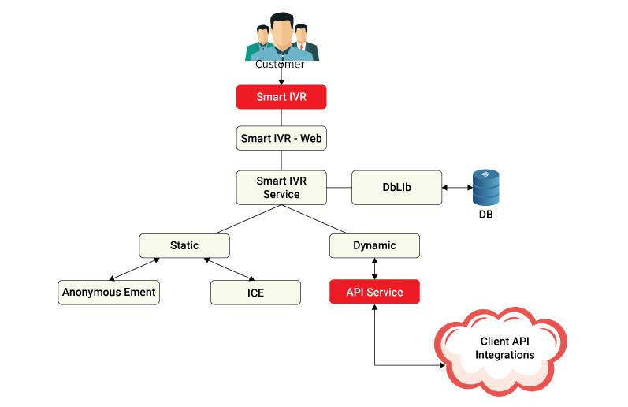The gPlex® Smart IVR web will get a request from a smartphone. To give clients dynamic service, the SIVR service will collect information from the City Bank ecosystem via API, play static announcements and obtain Instant Customer Endorsement (ICE), as well as retrieve database information from the database using DbLIb.

#### 

#### Figure 2: gPlex® - Smart IVR

#### **2.6.1.1 Smart IVR Features of gPlex®**

* No need for the customer to memorize the DTMF for the relevant service node.
* Both smartphones and tablets are compatible with gPlex SMART IVR as long as the phone has internet access.
* The gPlex SMART IVR service does not require the customer to install any apps in order to use it.
* gPlex SMART IVR service is created with the concept of responsive design, which means that based on the customer's smartphone/tablet screen size all the menus will be aligned according to the screen aspect ratio.
* Through backend interaction with the client ecosystem through API, customers may quickly observe or obtain service from the gPlex SMART IVR.
* Company management may broadcast brief messages to all live consumers utilizing SMART IVR services in gPlex using the news bulletin capability.
* Additionally, the gPlex SMART IVR supports simple forms that customers may send directly to the business. Customers will no longer need to visit the bank to use the online banking service; instead, they may submit the form to the bank using the gPlex SMART IVR.
* For further security during financial transactions, the gPlex SMART IVR may be linked with the gPlex OTP module.
* Integrate seamlessly with current IVR.
* improved routing, reduced zero-outs, and reduced call volume.
* The gPlex SMART IVR includes an ability to activate or disable sound as well as audio and visual representations of the IVR nodes. It also has backward and forward movement of the nodes.
* Rich consumer contact reporting is available to management. Service Report, Service Summary, Interactive Customer Endorsement Report, SMART IVR Menu, and Service Hit Count are a few examples.
* Since gPlex SMART IVR is an internet-based service, gPlex suggests setting up the deployment of the solution within the DMZ zone.
* Compared to the conventional IVR, the experience is the most user-friendly.

### **2.6.2. Call Blaster**



Figure 3: Call Blaster

gPlex® Call Blaster is a highly scalable automatic over-the-phone message broadcasting system. It can dial millions of numbers in a matter of hours. It can manage multiple campaigns simultaneously. Its management tool allows the setting of media changes, minimum and maximum ports, control of Calls per Second (CPS), and much more. The system comes with a real-time dashboard and rich reporting features including the provision of customized reports. The gPlex® Call Blaster is an independent system that can be deployed either as a stand-alone system or as part of a ‘Contact Center System’.

#### **2.6.2.1 Reach Millions in Hours**

With the help of the gPlex® Call Blaster system, firms may communicate with numerous contacts at once to convey pertinent information while operating under a single campaign. An application program interface (API) that is incorporated into the backend ecosystem can be used to deploy a built-in interactive voice record (IVR) system to collect customer feedback or carry out commercial operations. We work hard to give our business clients high-quality service encounters so they can pass those along to their clients.

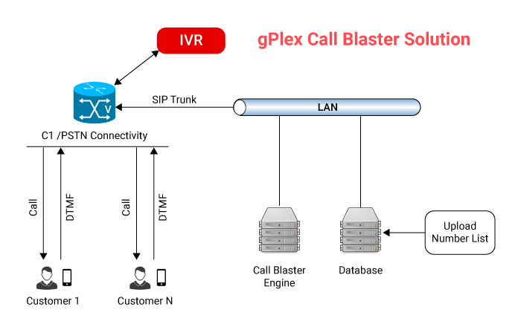

#### Figure 4: gPlex® Call Blaster Solution

#### **2.6.2.2 Benefits of gPlex® Call Blaster**

* Reach millions of customers in hours.
* Run several campaigns simultaneously.
* Real time dashboard for call statistics and sales count.
* Built-in IVR to obtain customer feedback.
* Can perform business processes through API integration.
* API-Interface to pull contact information from third-party CRM.
* Can upload millions of contact information in Excel, CSV, text format, etc.
* Automatic Language selection.
* Support STM-1/E1/SIP trunking.
* Stand-alone solution scalable to 2000 ports/channels per campaign.
* Zero capex and low opex.
* Service available through hosted platforms under the pay-as-you-go model.

#### **2.6.2.3. How gPlex Call Blaster do for your Business promotion?**

With gPlex® Call Blaster, you can call millions of customers with a customized voice message for getting feedback, promote your new product or service, inform them about your upcoming event, and much more! It is an online tool for automatic outbound dialing that plays your pre-recorded message as it scrolls through your phone numbers. With the aid of gPlex® Call Blaster services, you can inform your target audience about the most recent promotional offer or introduce them to a new product faster and more thoroughly than ever before.

**Special Promotion:**

Businesses often introduce time sensitive special promotional offers. The challenge is such offers must be communicated to a very large number of target customers within a short time window, say reaching out to millions within a couple of days. Creative call campaigns executed by gPlex® Call Blaster service may be the ideal solution to handle such situations efficiently. Integrated APIs may be deployed to automatically subscribe and deliver certain service products to previously registered customers. Examples of use: (i) Travel Agents promoting special occasion/event price discounts, (ii) Home improvement companies offering special discounts on specific items like flooring/carpeting for a limited period.

**Customer Feedback:**

As a customer satisfaction exercise businesses often need to obtain customer feedback following the delivery of their services. gPlex® Call Bluster service may be used to have those customers automatically called during a user-defined time window to obtain customer feedback on services they received. Example of use: (i) Car/AC/Heater repair shops seeking feedback from their customers who visited them recently.

**Emergency Messaging:**

Cities, Schools, and Businesses often need to send out emergency messages to their constituents/customers within a very short window. gPlex® Call Bluster service can offer a very effective and appropriate solution to handle such situations. Example of use: (i) School districts sending out school closure notice to all students/staff due to impending snow storm, (ii) Cities sending our flash flood warning-related calls to their citizens.

### **2.6.3. Mobile Banking Apps**

A bank or other financial institution's mobile banking service enables its clients to carry out financial transactions remotely using a mobile device, such a smartphone or tablet. For corporate clients, gPlex® mobile apps are practical and provide access to specialized services.



Figure 5: Mobile Banking Apps

#### 

#### **2.6.3.1. gPlex® Mobile Banking App Features**

|  |  |  |
| --- | --- | --- |
| Check the balance of your accounts | Mobile Top-up | View Summary of Credit Cards |
| View past transactions | Change TPIN (Banking PIN) | Pay your credit card and bill |
| Account overview | Email to Customer Contact Centre | View past billed statements |
| Transfer funds | Call to Customer Contact Centre | View unbilled transaction |
| Fund Transfer between own accounts | Set profile picture to personalize app | Balance transfer |
| Request for account statement | Frequently asked questions (FQAs) | Apply for a loan on credit |
| Schedule Fund Transfer | Locate nearby branches and ATMs | Report Lost / Damaged Card |
| View Scheduled Payments | Locate discount partners outlets | Regenerate Credit Card PIN |
| Bill / Utility Pay | Message/News board | E-statement of your Credit Card |

### **2.6.4. Advanced IT Training**

#### **2.6.4.1. Visit a professional and act like one!**

An information technology (IT) professional can build the technical skills necessary for a successful career at Genuity Training, a technical career center, via rigorous, hands-on training. In order to provide every qualified IT Professionals with a very specialized training package, Genuity Training offers a wide variety of IT training courses and programs.

**Why Genuity Training ?**

* Expert trainers
* Various programming courses
* A well-furnished and attractive labs
* Committed to providing quality services

Genuity takes considerable care when choosing highly qualified, multi-skilled professionals as instructors. When appropriate, they might discuss the advantages and disadvantages of the items and provide different approaches to solving problems. Visit www.genuitytraining.com for more information on Genuity Training.

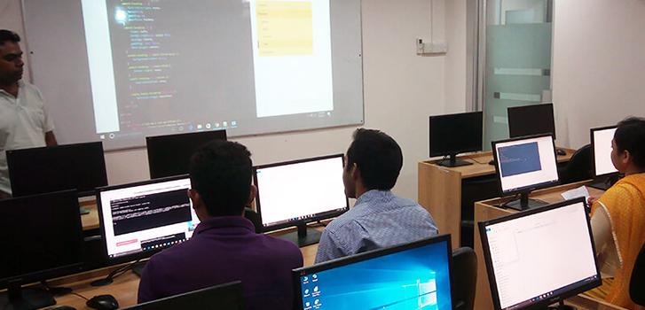

Figure 6: Genuity Training

**2.7. Solution**

**2.7.1. Contact center solution**



## 

## Figure 7: Contact Center Solution

#### **2.7.1.1. gPlex® - Enhancing Customer Experience!**

The gPlex® Contact Center solution is likely the most feature-rich, cost-effective, simple to setup, dependable, and highly scalable system, regardless of whether you need a cloud-based or on-premises contact center solution. No issue if you want your agents spread out geographically. The gPlex® Dashboard enables real-time, glance-based monitoring of contact center activity. Increased productivity and customer satisfaction are facilitated by swift realization. The gPlex® contact center solution generates various, highly useful reports and charts that help your contact center run smoothly. The gPlex® contact center solution is scalable and simple to deploy. While the core server is located at the central office, agents can be put remotely at various places.

#### **2.7.1.2. gPlex® Contact Center Feature**

|  |  |
| --- | --- |
| * Multi-channel ACD | * API for Telebanking |
| * Flexible IVR | * Voice logger |
| * Smart IVR ( Visual IVR ) | * Screen logger |
| * Blaster IVR / Agentless IVR | * Find last Agent |
| * Multi-location call route | * Dashboard |
| * Caller priority | * Wallboard |
| * Screen popup | * Predictive dialler |
| * Integrated CRM | * Unified agent desktop |
| * Mobile App for Supervisor | * Unified Reporting |
| * PCI-DSS compliant | * MoH with Filler |
| * Webchat | * Social Media integration |
| * Chatbot | * SMS/TEXT integration |
| * TTS, STT, ASR | * Work Force Management |

gPlex® Contact Center Solution is suitable for any size of contact center business. Efficient agent desktop softphone and one-touch keyboard functionality facilitate easy navigation and increased performance. It will improve efficiency through reduced manpower costs and increases overall profitability.For more details about gPlex® Contact Center solution please visit [www.gplex.com](http://gplex.com/)

### **2.7.2. Smart PBX Solution**

#### **2.7.2.1. Smart Business Phone Solution**

For a low price, gTalk® PBX offers a full range of business communications services tailored to each client's unique needs. Auto-attendant, call queuing, conference calling, do-not-disturb, and many more functions are available with gTalk® PBX. It enables businesses with various locations to function as one unit, increasing efficiency and using fewer resources. With our simple, plug-and-play gTalk® PBX system, your workers can now work from home or from any place in the world.

|  |  |
| --- | --- |
| * Auto Attendant | * Web-based portal |
| * Music on hold | * Call forwarding |
| * Called ID & name | * Call return |
| * Call waiting | * Mobile App |
| * Call Hold | * The Last number redial |
| * Call transfer | * Do not disturb ( DND) |
| * Call pick-up | * Find me/Fellow me |
| * IVR | * Voice mail |
| * Call park | * Call monitoring |
| * Ring Groups | * BLF (Busy Lamp Field ) |
| * Personalized greetings | * 3-way conference |
| * Conference-Bridge | * Page / Announcement (PA) |
| * Missed call indicator | * Speed dial |
| * Call history | * Simultaneous ring |
| * Voice Recording | * Advance call routing |

The gTalk® PBX service is adaptable enough to unite enterprises with different locations under a single PBX platform, scale up, and add users right away. The remedy is quite scalable. As your firm expands, you may add or enhance the expansion or capacity without worrying about installing new machinery.

### **2.7.3. Mobile Application**

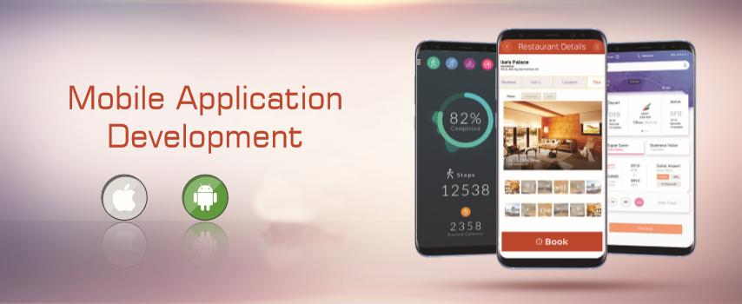

Figure 8: Smart Business Phone Solution

**INNOVATIVE CUSTOM MOBILE APPLICATION DEVELOPMENT**

Our vision to is help businesses in enhancing and project their image and boost performance through the development and maintenance of innovative aesthetically designed and user-friendly Smart Mobile apps.

#### 

#### **2.7.3.1. Types of Application:**

* Business apps
* Finance and Banking apps
* Health care apps
* E-commerce apps
* Telecom apps
* News & Magazines apps
* Voice related apps
* Entertainment apps

## **2.8. BPO Services**

### **2.8.1. Call Center Services**

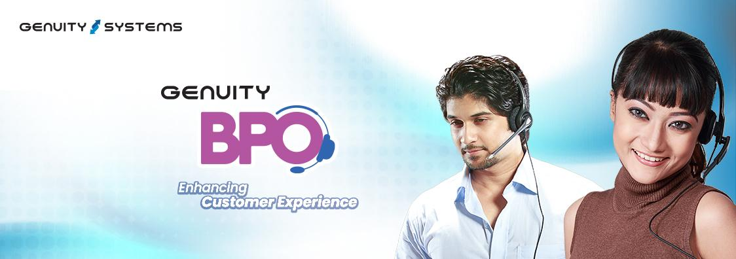

Figure 9: Call Center Services

Customers from a variety of industries, including banking and finance, healthcare, insurance, manufacturing, travel and hospitality, automotive, energy utilities, logistics, retail and consumer, telecommunication, and others, can take advantage of Genuity BPO's best-in-class call center services, both inbound and outbound. We offer round-the-clock call center services so you can keep in touch with your clients and consumers and deliver business solutions.

We provide startups, medium-sized businesses, and major corporations (gPlex) call center services that are technologically advanced, high-quality, and reasonably priced. With cutting-edge technologies like Self-Service, Mobile Dashboard, Multilevel IVR, Smart IVR (VIVR), Phonetic Recognition, CIVR, Intelligent Routing, etc., we are one of the leading suppliers of enterprise call center solutions in Bangladesh and the USA. Customers receive outstanding information or technical help from our knowledgeable and committed staff.

#### **2.8.1.1. Contact Center Service**

* Inbound Call Center
* Outbound Call Center
* Tele Marketing/ Tele Sales
* Chat Support Services
* Email Support Services
* Customer Care Services

### **2.8.2. Why Select Genuity BPO as a Partner for Call Center Outsourcing Services?**

**Assure High Quality of Services**

Genuity BPO pledges to uphold the highest levels of customer service excellence. Our quality assurance team carefully monitors and controls that all call center activities are carried out in accordance with the established standards. Our sector specialists are on standby to guarantee the deliverables.

**Enhanced Customer Satisfaction**

As a top provider of call center solutions, we provide a range of outsourced customer engagement channels, including phone, email, live chat, social media, etc., to help you quickly reach a large number of customers, which in turn increases customer satisfaction & retention.

**Make Use of Analysis**

Our all-encompassing Analytics offer vital information on how your brand is performing and how valuable it is to the market, enabling consumers to comprehend the product completely. The right analytics and data improve customer service and increase profitability.

**Work with Best-in-Class Technology**

The most recent technologies, including Self-Service, Mobile Dashboard, Multilevel IVR, Smart IVR, Phonetic Recognition, etc., are used across our contact center outsourcing services to successfully integrate them with Customer Relationship Management solutions. Our outsourced contact center solutions assist companies in offering technologically advanced international call center services.

**Regular Training to the Team**

Our call center outsourcing services personnel receives continuous training and development in order to retain their excellent communication skills and stay up with changes in the industry.

**Email Response & Help Desk**

As a leading provider of call center services worldwide, we make sure that our clients receive continuous assistance. We offer a consistent and relevant customer care experience through a single point of contact, and we promptly address inquiries from customers along the sales process.

## **2.9. Company Hierarchy**

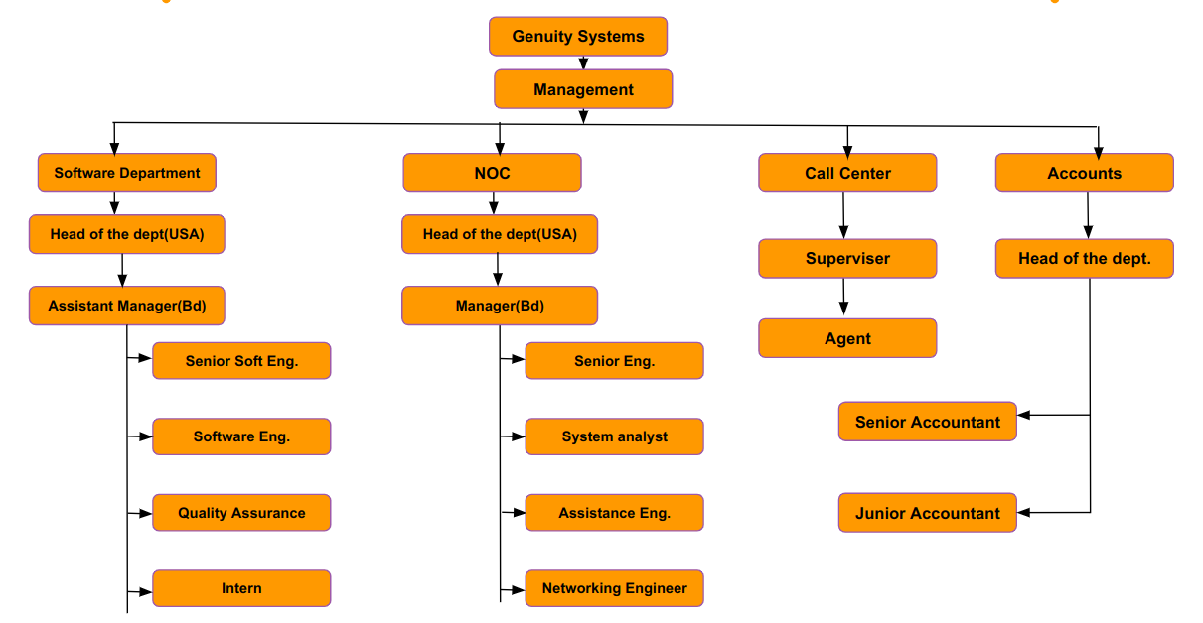

Figure 10: Company Hierarchy

## **2.10. Office Culture and Environmen****t**

## **2.10.1. Overview**

## One of an organization's most crucial resources is its human capital. An organization's effectiveness and success are dependent on its employees. So it's crucial to offer both a professional setting and a healthy, welcoming environment. Genuity thinks that while on the job, employees should be emotionally and physically healthy and totally love what they do. Therefore, Genuity offers all the amenities required for staff members' rest while doing their creative duties.

### **2.10.2. Friendly Working Environment**

The office space at Genuity is fantastic for working in because it was especially created for a software development business. It has taken great effort to design a space that actively promotes information sharing and teamwork at work, from color choices to furniture placement.

I worked at Genuity as an intern for six months. None of the members could tell us apart from the other workers. Everyone in the group is quite cordial. They assist us in adjusting to new situations and difficulties. Additionally, the welcoming atmosphere allows us to mentally recharge after long periods of labor.

### **2.11.3. People**

Genuity recruits problem-solvers rather than developers, designers, or QA engineers. And it only works with the greatest. To maintain staff members at the top, it holds frequent training and review sessions. Additionally, its culture of learning, sharing, and constructive criticism broadens our horizons and keeps staff members composed.

### **2.11.4. Beware of the Meeting**

The Genuity Systems Ltd. personnel have developed the practice of being aware of the meeting. Because they think that the only tool available to them to capture attention, convey project progress, clarify product direction, and pinpoint any problems or obstacles is a meeting. Every team member attends these sessions, even though not everyone participates in speaking. In addition, a meeting is necessary to ensure that the project is virtually always progressing. Everyday presence helps everyone stay on task and get ready for the day. It enables the project's emphasis to be more effectively determined.

### **2.11.5. Self Responsibility**

Responsibility is defined as "response-ability," or the capacity to select a single answer. Employees at Genuity are responsible, very proactive individuals. They do not attribute their actions to external factors like conditions or conditioning. Instead of being a result of their circumstances or a result of their feelings, their actions are an intentional decision they made based on their ideals. One must take full responsibility for his or her life if they want to succeed significantly in life. Less won't do at all. The employee always assumes that the occurrence and the answer will lead to the desired result. The Event + Our Response = The Result

### **2.11.6 Keep the workplace Comfortable**

There is little question that the physical and social aspects of the workplace play a significant role in determining whether employees are pleased or not. Many businesses find it difficult to distinguish between what is necessary and what is lavish as a result of the intense focus on cutting expenses in order to keep pricing low. Lack of friction in the office and frequent absences are not signs of a comfortable workplace, according to research. By providing employees with a kitchen with a refrigerator where they can store food they've purchased from the market, sufficient lighting, comfy workstations and chairs, pleasant office design, and a peaceful environment, Genuity guarantees that their workplace is safe and comfortable for them to work in. The most frequent issue with offices is the temperature, and Genuity makes sure that every space has air conditioning (AC), demonstrating that the workplace is at the ideal temperature for employees to work in.

### **2.11.7. Being Humble**

Success in life or in work comes from being humble. There are numerous leaders who are held in high regard nowadays. The image of CEOs is one of omnipotent superstars. Everyone should strive to be modest. In addition to that culture, Genuity displays a few others. Intelligence and conscientiousness are two of the top indicators of achievement, both in the classroom and on the work, but humility predicted performance better than both.

### **2.11.8. An honest approach to business and trust in each other**

According to conventional wisdom, the brand of honesty strategy must come before brand perfection, which is the largest fallacy. Trust is the cornerstone of effective cooperation. Each team member must endeavor to build trust, nurture it via his or her words and deeds, and work to keep it. Each team member must also be able to rely on the other members to commit to the team and its objectives, to work effectively toward those objectives, and to communicate consistently about any matters that may influence the team.

### **2.11.9. Dress Code**

In Genuity, there is no set dress code. The majority of employees wear casual attire. However, wearing unconventional attire to the office is not permitted.

### 

### 

### **2.11.10. Special Day Celebration**

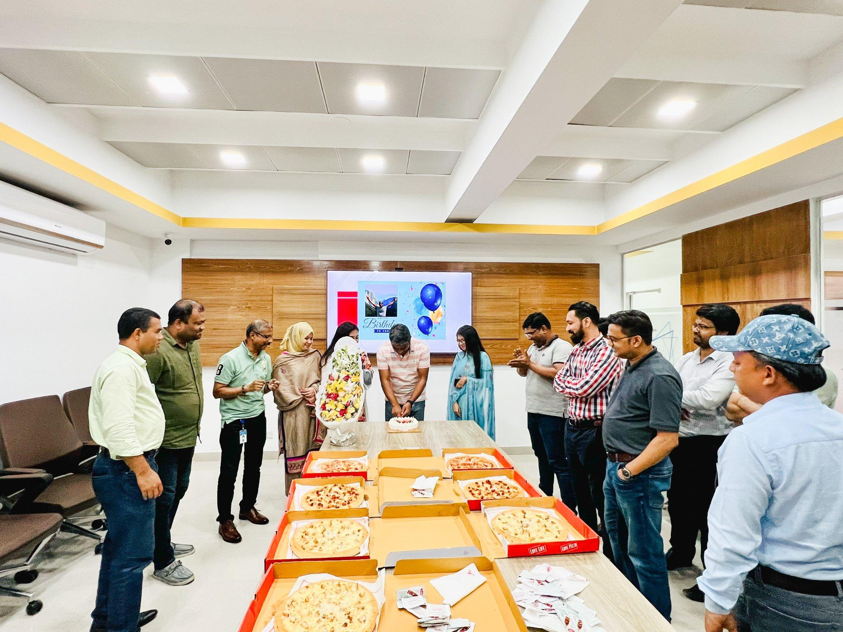

Figure 11: Birthday Celebration of Abdullah Vai (Middle)

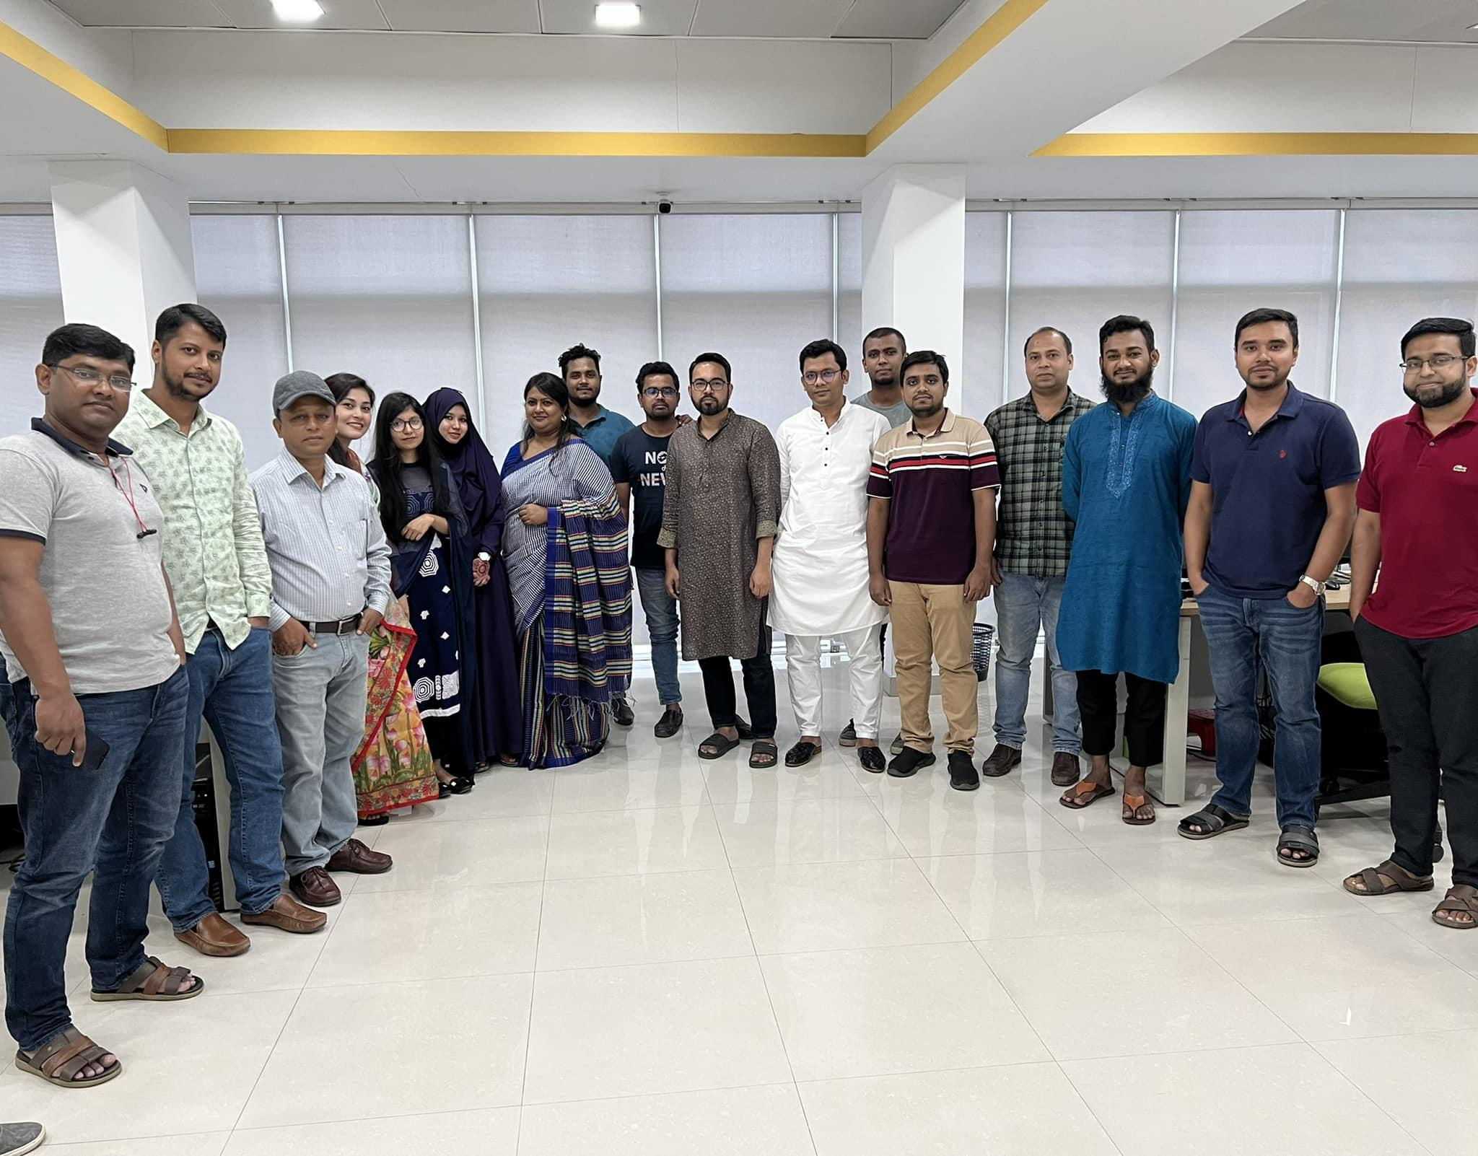

Figure 12: Eid celebration



Figure 13: Genuity 19th anniversary celebration

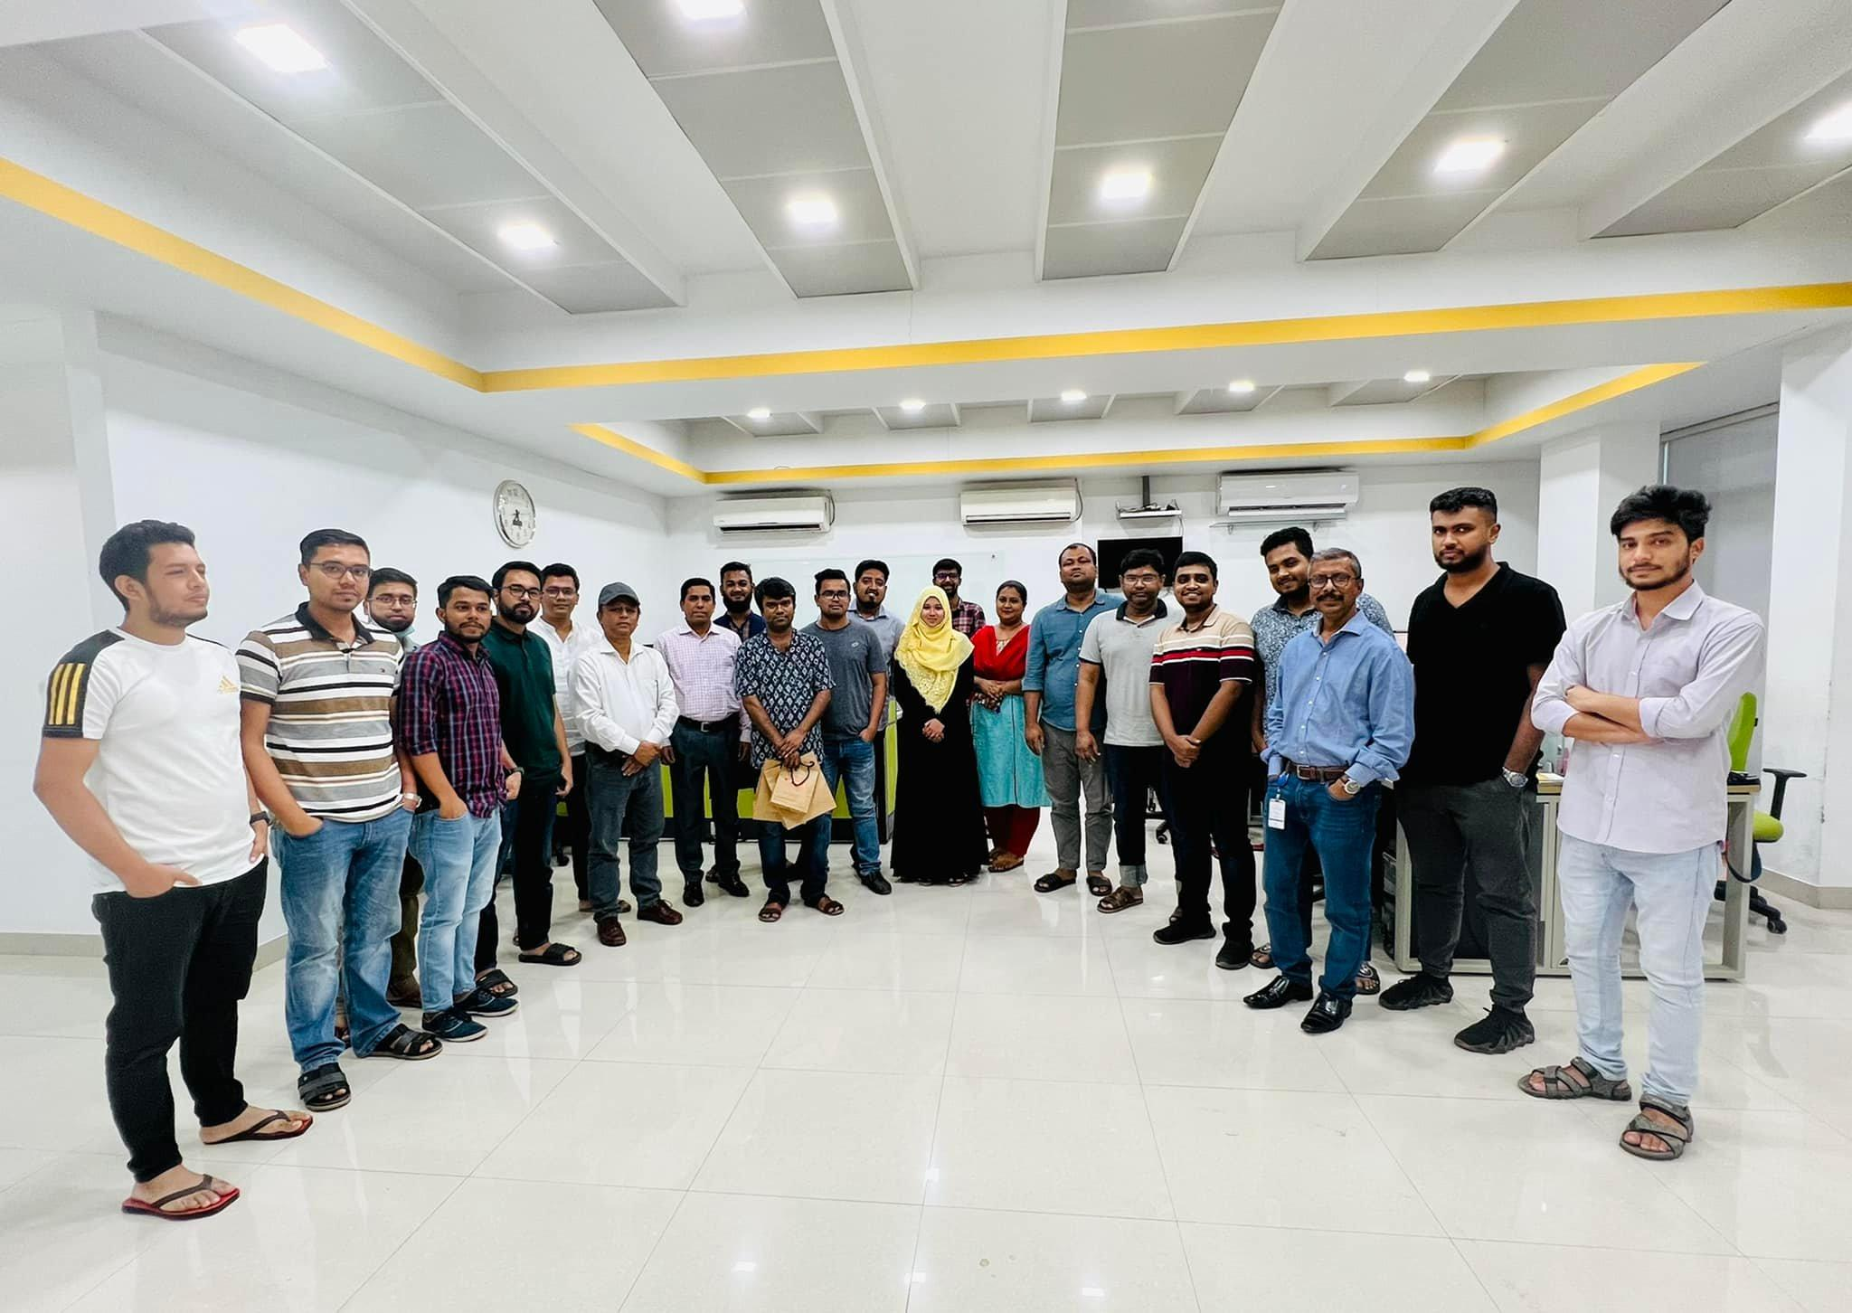

Figure 14: Farewell of an employee

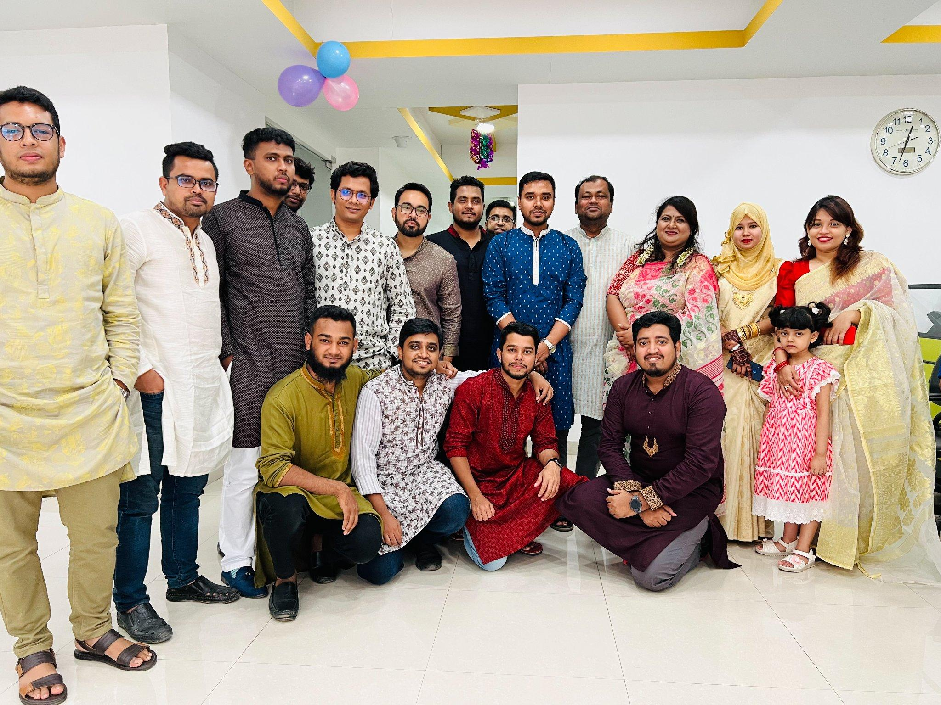

Figure 15: Pohela Boishakh Celebration

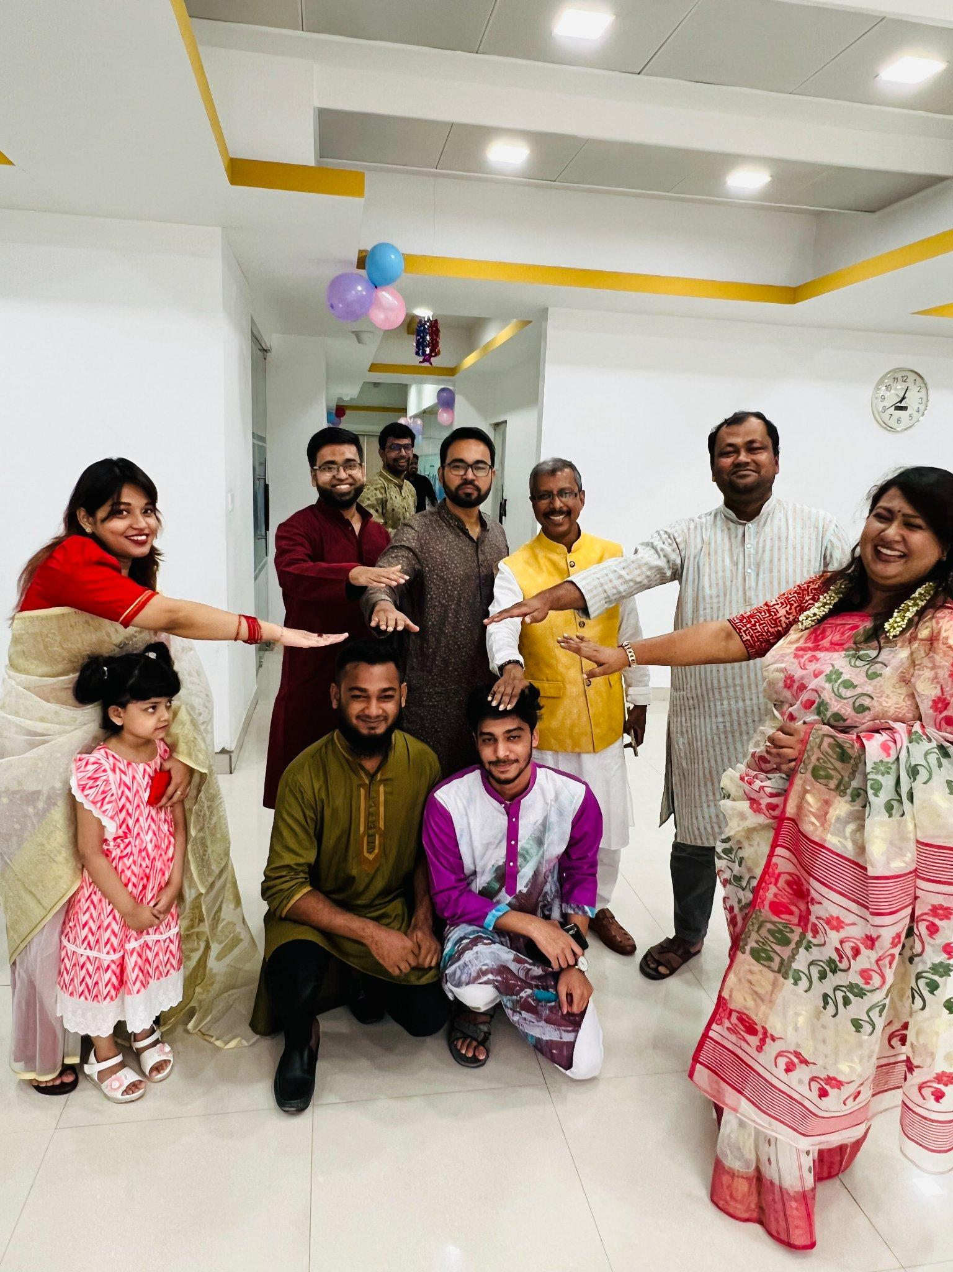

Figure 16: Blessing us to be married in pohela boishakh celebration

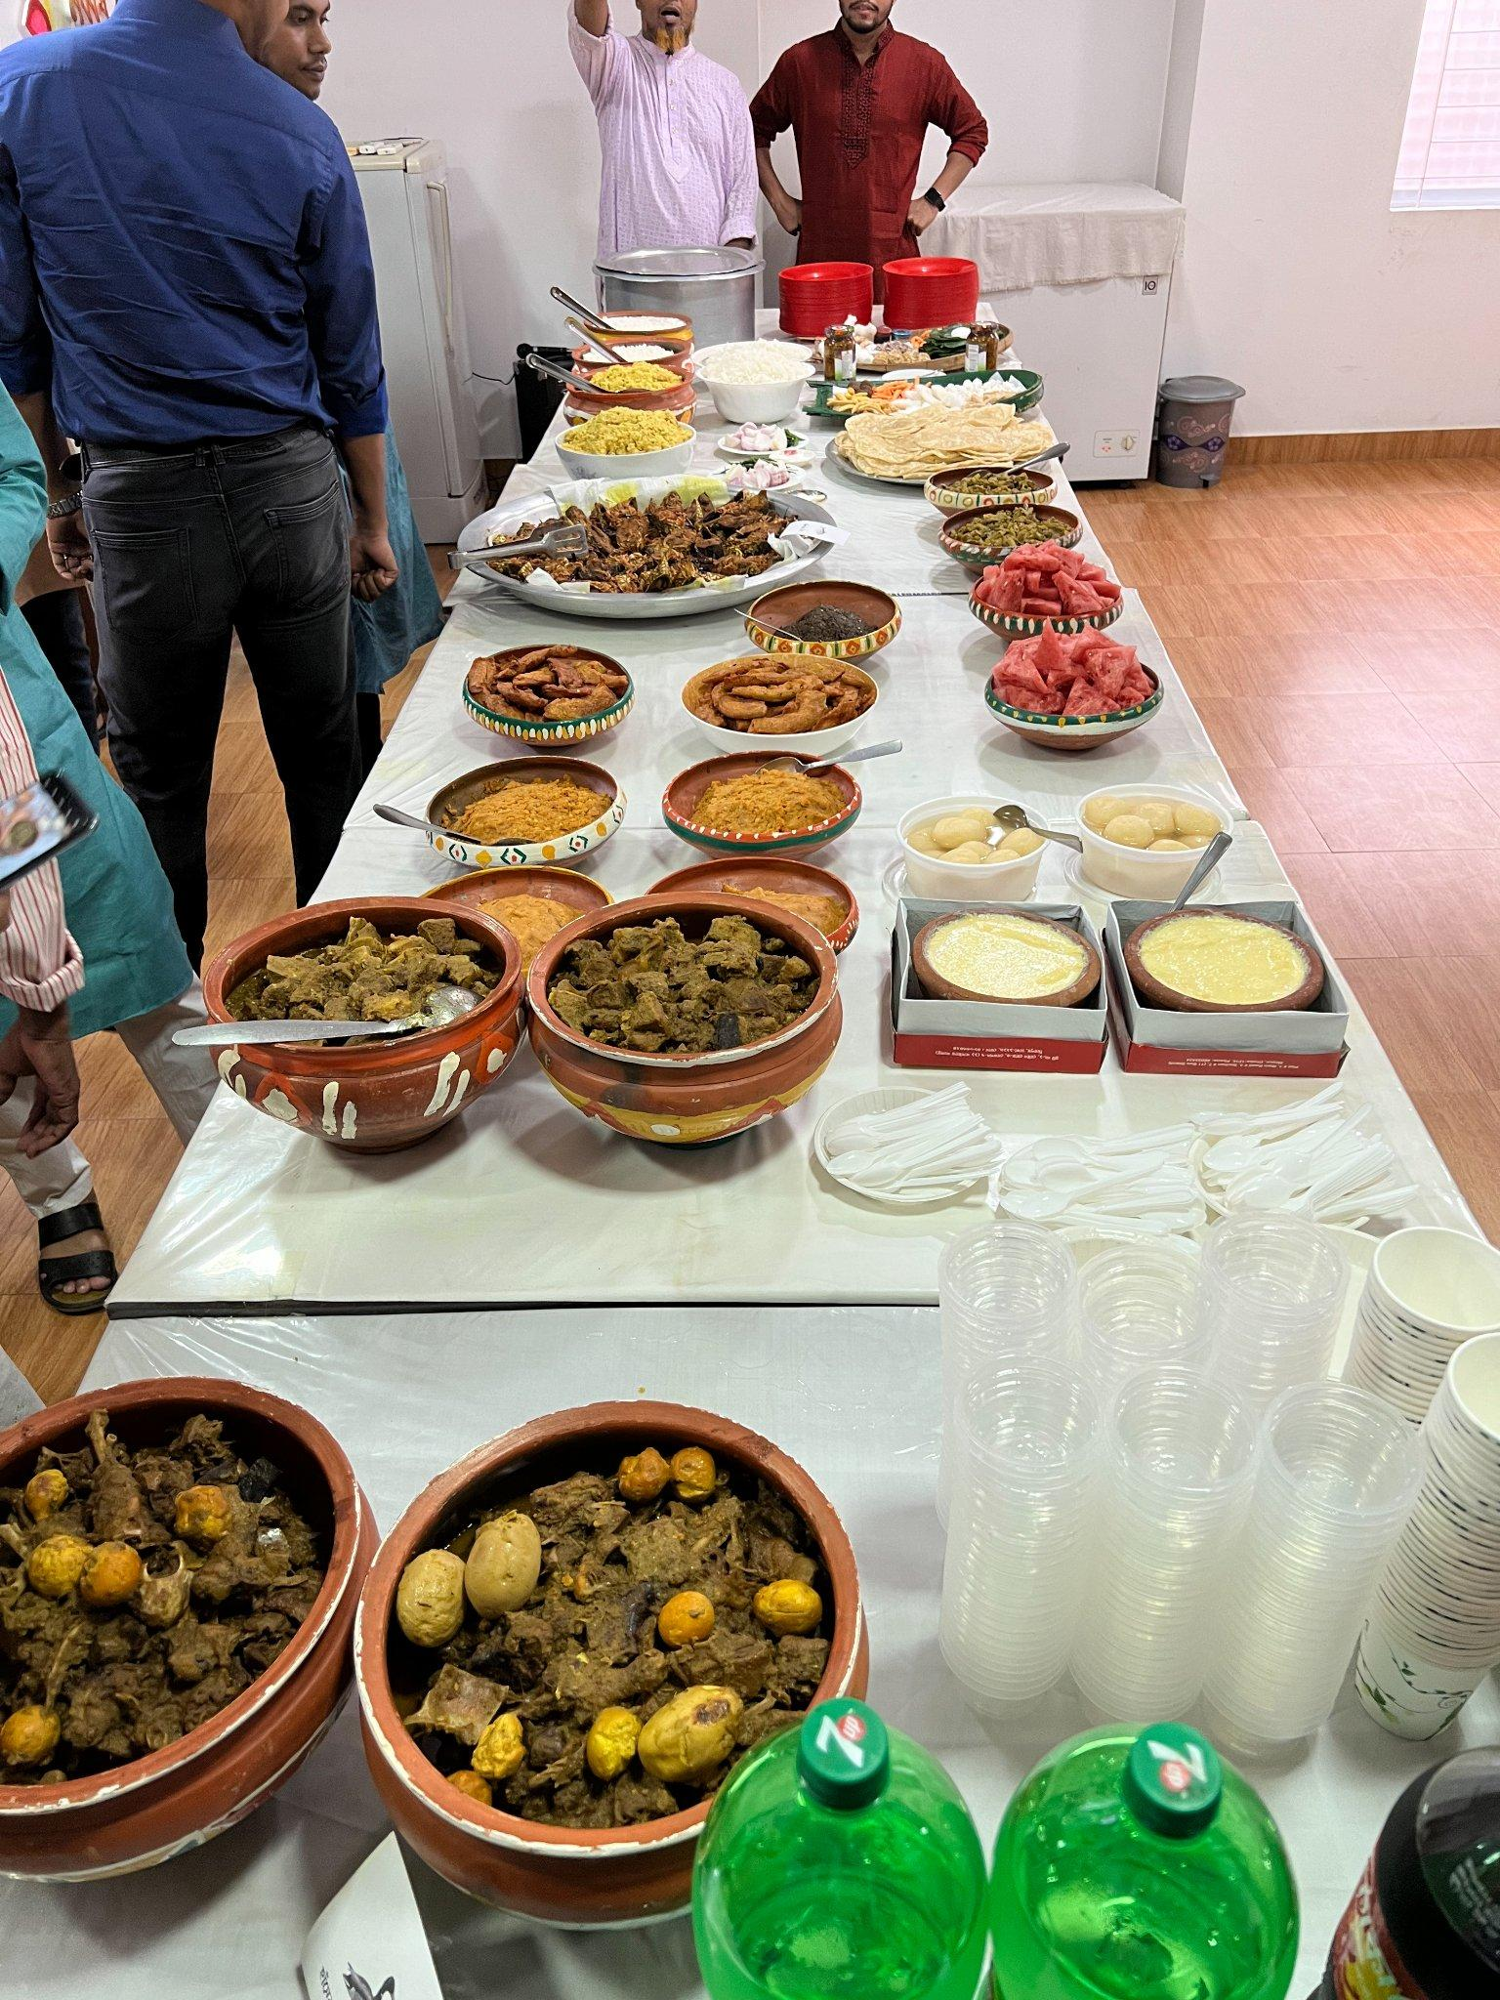

Figure 16: Food provided from the office in Pohela Boishakh Celebration

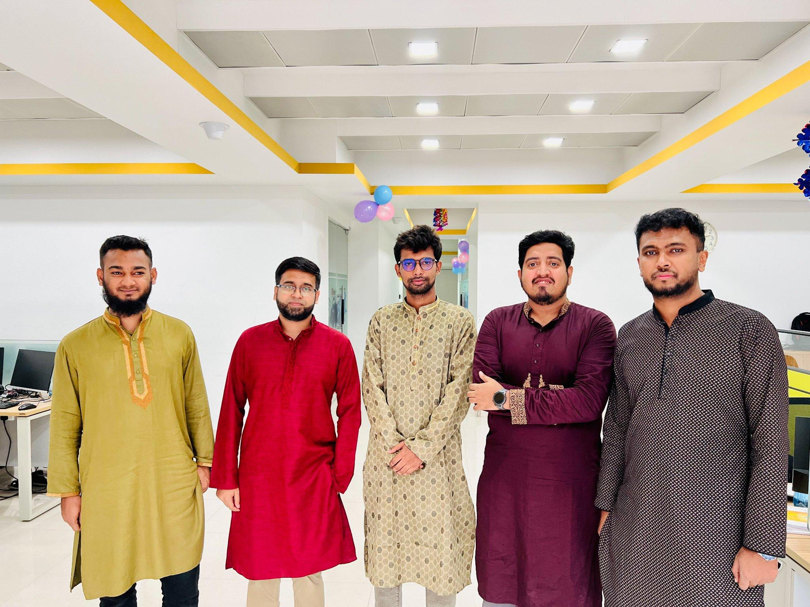

Figure 17: Machine Learning Team in Pohela Boishakh

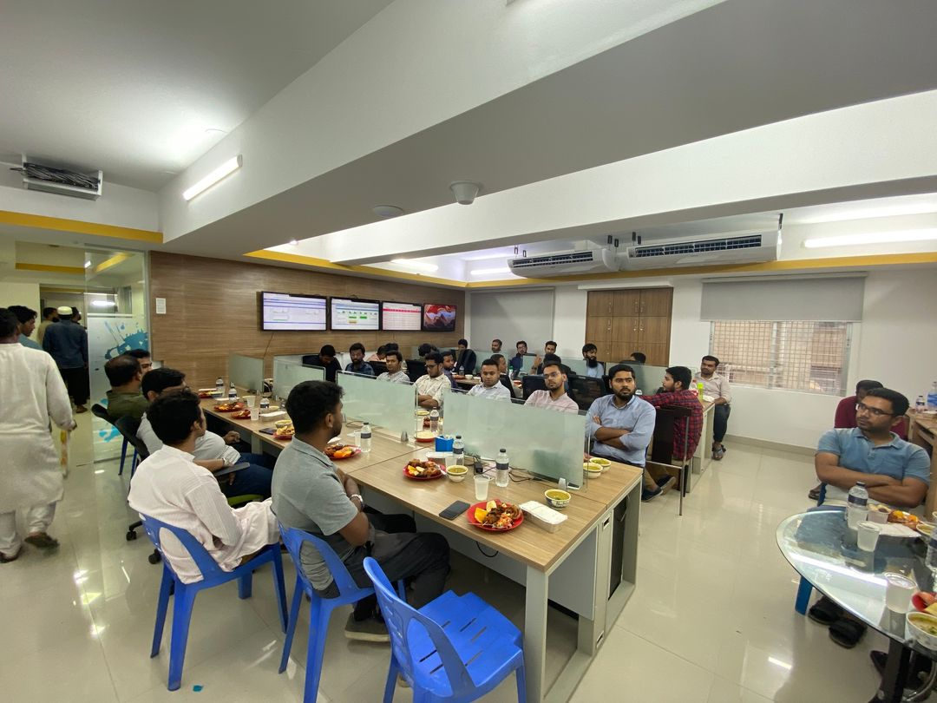

Figure 18: Iftar Party

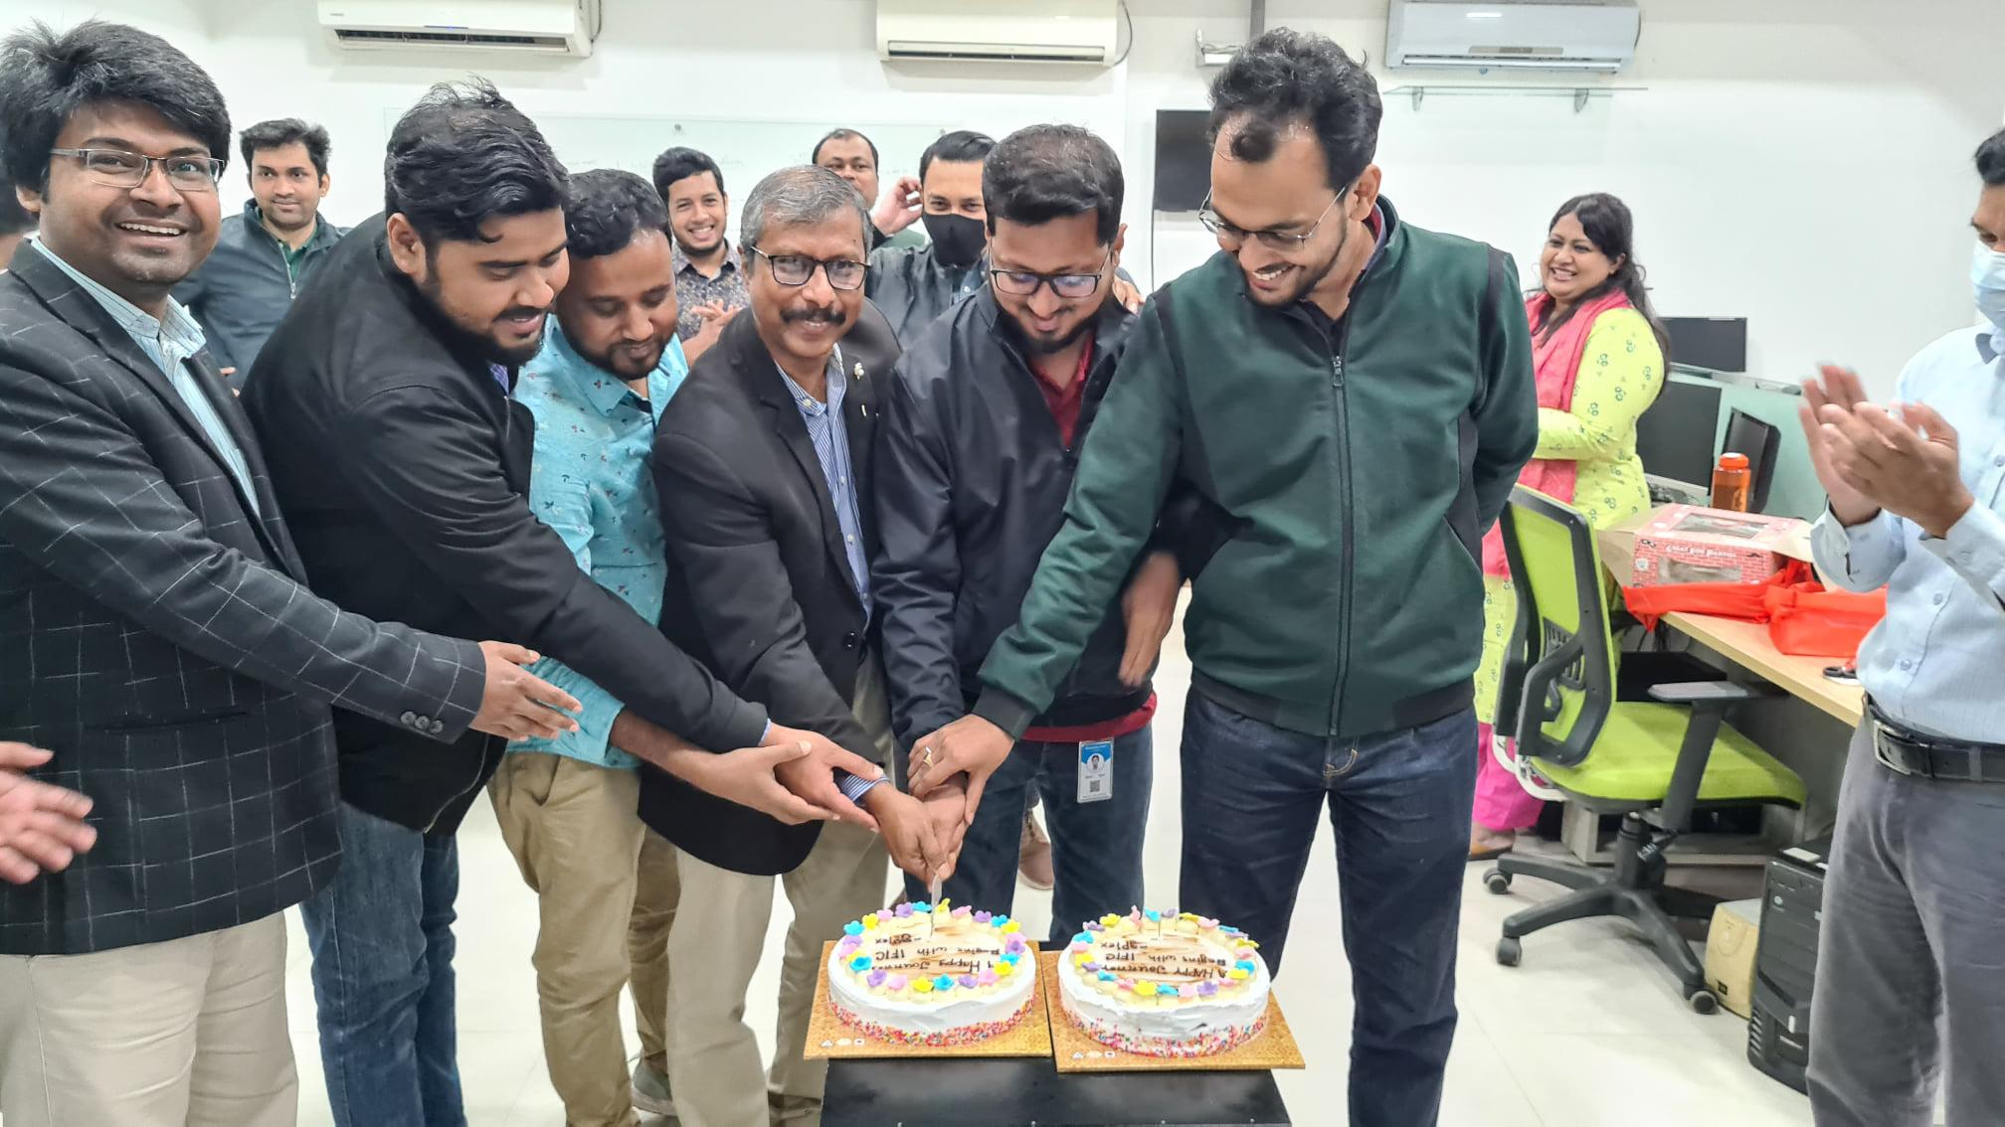

Figure 19: Journey Begins with IFIC Bank

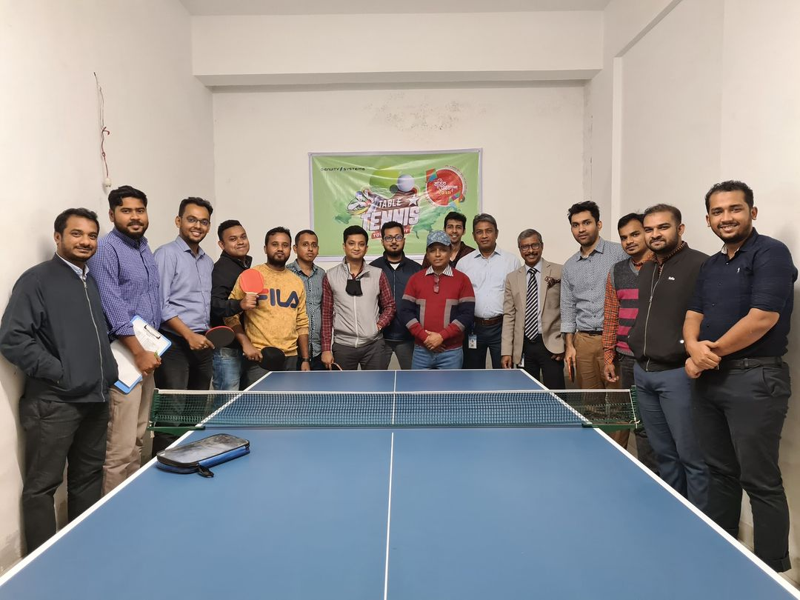

Figure 20: Table Tennis Championship

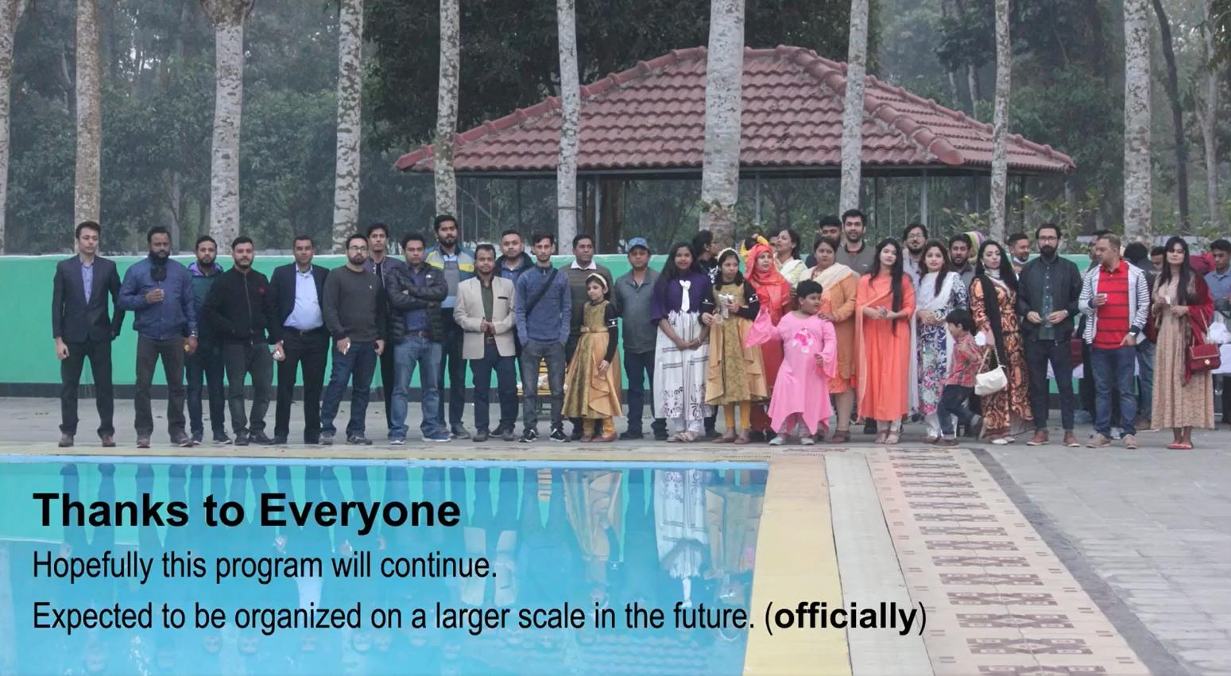

Figure 21: Annual Picnic

## **2.11. Office Schedule**

Office hours are 9:00 a.m. to 6:00 p.m., Sunday through Thursday. For lunch and prayers, there is a one-hour break starting at 12:01 PM, and there is a 15-minute tea break.

## **2.12. Facilities for Employees**

Salary is only one of the two factors in the two-factor hypothesis of work satisfaction. High productivity requires characteristics that promote motivation. The staff at Genuity Systems Ltd. have access to a number of amenities.

### **2.12.1. Domestic Environment**

It's like one huge family, genuity. The whole Genuity team, both present and former, is a part of this family. Our work is enjoyable. Employees believe that they are responsible for the firm.

### 

### **2.12.2. Lunch and snacks**

The workplace provides lunch for the workers. They offer endless tea and a variety of foods every five days. Every department also appoints a food manager for a month at random from among its staff. Office Give the department manager 5,000 taka, and he will expense the money for each of the department's employees. Therefore, the management makes an effort to always have snacks available, such as biscuits, chanachur, coffee, chips, seasonal fruits, and even ice cream.

### **2.12.3. Comfortable Sitting Arrangement**

Genuity offers comfy seats that are height and arm adjustable for developers who spend hours working while seated in the same chair and staring at their workstations.

### **2.12.4 Dinning and Prayer Room**

The third level of the office houses both the dining room and the prayer room.

### **2.12.5. Games**

Actually in Genuity Systems Ltd. there are only Table tennis Games Facilities.

# **Chapter 3: Internship Details**

## **3.1 Joining Letter**

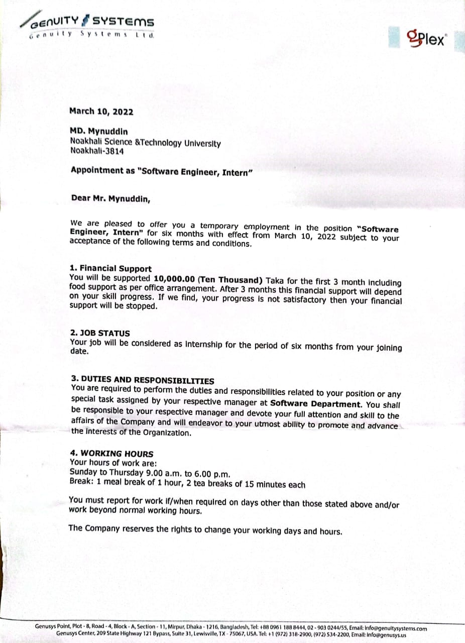

Figure 22: Joining Letter

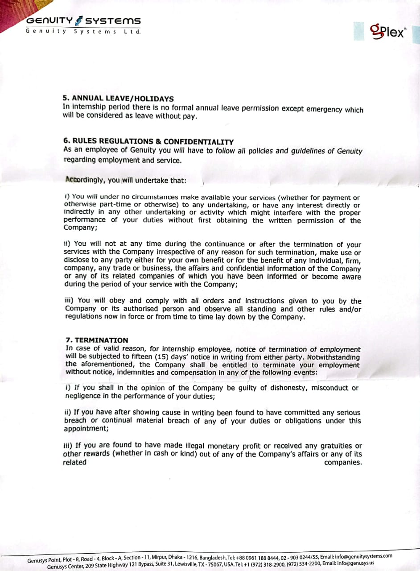

Figure 23: Joining Letter

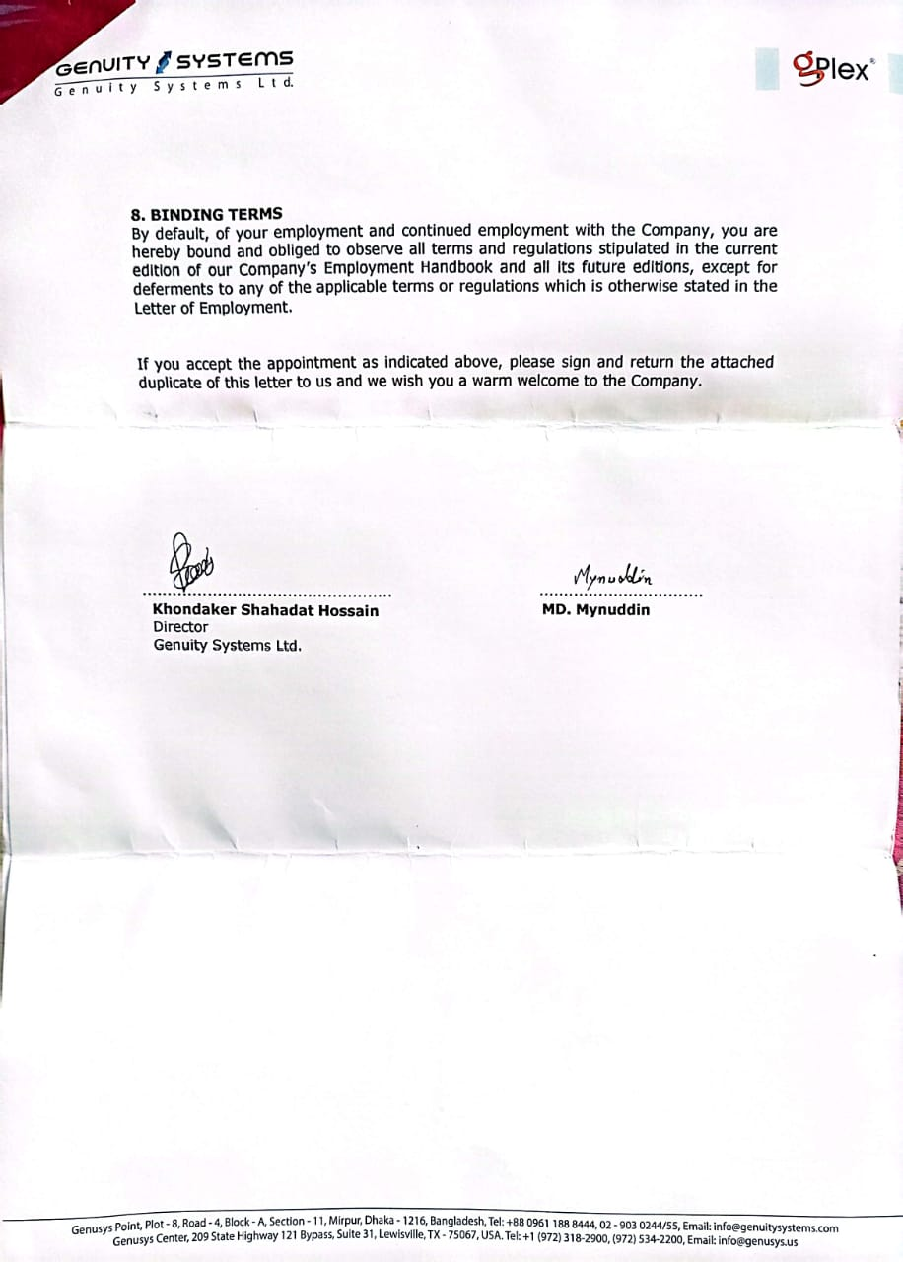

Figure 24: Joining Letter

## **3.2. Assigned Team**

**Working Team**

|  |  |
| --- | --- |
| **Machine Learning Team** | |
| **Name** | **Responsibility** |
| Team Leader | Nafees Mahbub  Software Engineer  Genuity Systems Ltd. |
| Team member | Emrul Hasan Zawad  Software Engineer  Genuity Systems Ltd. |
| Team member | Rifat Hasan  Software Engineer  Genuity Systems Ltd. |
| Team member | Azizul Hakim  Software Engineer  Genuity Systems Ltd. |
| Team member | Md Mynuddin  Software Engineer Trainee  Genuity Systems Ltd. |

## **3.3. First day at office**

When I got my joining date, I was extremely glad, yet as the date came closer, I was somewhat apprehensive. Numerous inquiries involved my cerebrum like in what manner will be the air of the workplace, will I have the capacity to modify with the associates, will I have the capacity to function admirably and completer targets, and so on. I came in at about 9:00 am on the first day and my boss welcomed me warmly and introduced me to my team, Managing Director,

and other employees. He showed me where my desk was and told me that he and my team leader would help me get started. He was very helpful and I sat next to him for the morning and just watched what he did. At lunch, my boss and the staff of the office invited me to lunch. I was so nervous; I could hardly eat a thing! We were gone for about 1-1.5 hours and just talked about the company, my studies, etc. After lunch, my team leader took me on a tour of our floor. Introduced me to everyone, showed prayer place, and all that good stuff, and me where the kitchen was, how the coffee machine worked, and where the copy machine was. I had some time to myself to figure out the new computer system and just look around. My day ended at 6.00 pm. It was a great first day.

## **3.4. Technical Skill I learn**

As I join the Machine learning team and if I wanna work on a real-life project I need to achieve many skills. So my team leader provides me with the necessary resources and I follow his instruction. Below I mentioned the list of my learning topics.

### **3.4.1. Python**

* Basic python
* Data Structure
* File handling
* Function
* Module
* Array and String
* Working with Image
* OOP Concept
* Special Variable
* Advanced Function
* Comprehension
* Numpy
* Pandas
* Exploratory Data Analysis( EDA)

### **3.4.2. Statistics**

|  |  |  |
| --- | --- | --- |
| **Basics Stats** | **Intermediate Stats** | **Advanced Stats** |
| Introduction to basic terms | Standard Normal Distribution *** | Q-Q plot |
| Variables | Z score *** | Chebyshev’s inequality |
| Random Variables | Probability Density Function *** | Discrete And Continuous Distribution |
| Population, Sample,Population Mean | Cumulative distribution function | Bernoulli And Binomial Distribution |
| Sample Mean | Hypothesis Testing *** | Log Normal Distribution *** |
| Population Distribution, Sample Distribution and Sampling Distribution | Many different plotting graphs | Power Law Distribution |
| Mean, Median,Mode , Range | Kernel Density Estimation | Box-Cox Transform |
| Measure Of Dispersion | Central Limit Theorem *** | Poisson Distribution |
| Variance | Skewness of Data | Application Of Non Gaussian Distribution *** |
| Standard Deviation | Covariance *** |
| Gaussian/Normal Distribution *** | Pearson Correlation Coefficient *** |
| Spearman Rank Correlation Coefficient *** |
| Importance of Correlation *** |
| All Hypothesis Testing *** |
| R-Squared vs. Adjusted R-Squared: What's the Difference? |

### **3.4.3. Data Visualization**

* Matplotlib
* Seaborn

### **3.4.4 Machine Learning**

#### **3.4.4.1 Data Preprocessing**

* EDA
* Feature Engineering
* Feature Selection
* Feature Transformation
* Dimensionality Reduction
* Handle Imbalance Dataset
* Cross Validation
* Correlation
* Multicollinearity

#### **3.4.4.2 Supervised Machine learning**

* Linear Regression for single variable
* Linear Regression for Multiple variable
* Polynomial Regression
* Ridge and Lasso Regression
* Logistic Regression
* SVM(Support vector machine)
* Decision Tree
* Naive Bayes
* KNN(K-Nearest Neighbour)
* Ensemble Technique
  + Bagging
    - Random Forest
  + Boosting
    - Gradient Boosting
    - XGBoosting
    - AdaBoosting

#### **3.4.4.3 Unsupervised Machine Learning**

* Clustering
  + Hierarchical Clustering
  + K-means Clustering
  + DBSCAN

I study all these algorithms in-depth theory with implementation and create a report. Here is a sample of a report.

Problem statement: Emotion Detection for Bangla dataset.

Dataset description: we need to detect the emotion of the text, is it normal text or angry text? In this dataset, there are two feature

1.text_bangla : bangla text

2.audio_emotion : emotion of the text .(A-Angry text , N-Normal text)

|  |  |
| --- | --- |
| text_bangla | audio_emotion |
| এজেন্ট আউটলেটে গিয়েছিলেন | A |
| আচ্ছা ম্যাম আপনি তো অফারটি সম্পর্কে জানতে চাচ্ছিলেন আমি চেক করে দেখে আপনাকে জানিয়ে দিচ্ছি ম্যাম কিছুটা | A |
| এখান থেকে আমরা আপনার কোনো বাইক লোন দেখতে পাচ্ছি না এই ফোন নাম্বারের অ্যাগেইন্সটে এই ফোন নাম্বারের অ্যাগেইন্সটে | A |
| আপনাদের মিসটেকের কারণে হু ইজ নাউ আনফরচুনেট আমি আমার দুর্ভাগ্য এটা | A |
| স্যার আপনাকে তো অথরাইজ নাম্বার থেকে কল করতে হবে আদারওয়াইজ তো আমরা এখান থেকে | A |
| স্যার বর্তমানে আমি আমাদের ইন্ড থেকে দেখতে পাচ্ছি আপনার নাম্বারটিতে | N |
| স্টার জিরো হ্যাশ ডায়াল করে কম্বো বান্ডেল থেকে সেখানে থেকে নিতে পারবেন | N |
| আচ্ছা স্যার বুঝতে পেরেছি স্যার এ রকম কোনো কল এখন থেকে রিসিভ করবেন না তাহলে অসুবিধাগুলো হবে না আপনার | N |
| একটু সময় দিন আপনার এরিয়াতে নেটওয়ার্কজনিত কোনো সমস্যা আছে কিনা সেটি চেক করে আপনাকে জানাচ্ছি ঠিক আছে | N |
| ধন্যবাদ স্যার আপনার মূল্যবান সময় দিয়ে আমাকে সহযোগিতা করার জন্য | N |

Solution : Here I need to build a model, where users provide input and the model detects the emotion of the text.like,

Input : আমার সিম এ এতো বেশি টাকা কাটে কেন?

Output : Angry

Input : স্টার এইট ত্রিপল ফোর হ্যাঁশ

Output : Normal

I apply different algorithms and try to find the best one which provides me the best output. Here is the report for each algorithm.

**1.Naive Bayes Algorithm**

**Classification Report**

|  |  |  |  |  |
| --- | --- | --- | --- | --- |
|  | precision | recall | f1-score | support |
| 0 | 0.57 | 0.77 | 0.65 | 22 |
| 1 | 0.75 | 0.54 | 0.63 | 28 |
| accuracy |  |  | 0.64 | 50 |
| macro avg | 0.66 | 0.65 | 0.64 | 50 |
| weight avg | 0.67 | 0.64 | 0.64 | 50 |

**Confusion Matrix**

|  |  |
| --- | --- |
| TP = 17 | FP = 5 |
| FN = 13 | TN = 15 |

Accuracy : 64.0%

**2.K-Nearest Neighbour**

**Classification Report**

|  |  |  |  |  |
| --- | --- | --- | --- | --- |
|  | precision | recall | f1-score | support |
| 0 | 0.54 | 0.86 | 0.67 | 22 |
| 1 | 0.80 | 0.43 | 0.56 | 28 |
| accuracy |  |  | 0.62 | 50 |
| macro avg | 0.67 | 0.65 | 0.61 | 50 |
| weight avg | 0.69 | 0.62 | 0.61 | 50 |

**Confusion Matrix**

|  |  |
| --- | --- |
| TP = 19 | FP = 3 |
| FN = 16 | TN = 12 |

Accuracy : 62.0%

Using hyperparameter tuning (for K-neighbour = 1)

**3.1.SVM(using default parameter)**

**Classification Report**

|  |  |  |  |  |
| --- | --- | --- | --- | --- |
|  | precision | recall | f1-score | support |
| 0 | 0.54 | 0.86 | 0.67 | 22 |
| 1 | 0.80 | 0.43 | 0.56 | 28 |
| accuracy |  |  | 0.62 | 50 |
| macro avg | 0.67 | 0.65 | 0.61 | 50 |
| weight avg | 0.69 | 0.62 | 0.61 | 50 |

**Confusion Matrix**

|  |  |
| --- | --- |
| TP = 19 | FP = 3 |
| FN = 16 | TN = 12 |

Accuracy: 62.0%

### 

### **3.4.5. Audio signal processing for machine learning**

* Overview of Audio Signal Processing
* Sound and waveforms
* Intensity, Loudness and Timbre
* Understand Audio Signal
* Types of Audio Features
* How to Extract Audio Feature
* Time Domain Feature
* Fourier Transform
* Defining the Fourier Transform using Complex numbers
* Discrete Fourier Transform
* Short Time Fourier Transform
* Mel Spectrograms
* MFCCs

### **3.4.6. Bash Script**

* How to build bash script
* Variable and shell expansion
* How to bash process Command line
* Request user input
* Logic
* Processing options and Reading files
* Array and for loops
* Debugging
* Scheduling and Automation
* Working on remote servers

### 

### **3.4.7. Neural Networks**

* Perceptron (Single layer Neural Network)
* Multilayer Neural Network
* Forward Propagation
* Backward Propagation
* ANN - Artificial Neural Network
* RNN - Recurrent Neural Network
* CNN - Convolutional Neural Network
* Activation Function
* ReLU
* Leaky ReLU
* ELU
* Swish
* Softmax
* Softplus
* Sigmoid
* Optimizer
  + - Gradient Descent
    - Stochastic Gradient Descent
    - SGD with momentum
    - Adagrade
    - Adadelta and RMSProp
    - Adam
* Loss Function
* Probabilistic Loss / Classification Loss
  + Binary Cross Entropy
  + Categorical Cross Entropy
  + Sparse Categorical Cross Entropy
* Regression Loss
  + Mean Squared Error
  + Mean Absolute Error
  + Huber Loss
* Library: Mainly Keras, TensorFlow, Scikit-learn.

### **3.4.8. OpenCV**

During my internship at Genuity Systems Ltd, I was assigned a challenging project focused on face recognition, a topic I had not previously worked with. To overcome this challenge, I proactively engaged in learning and mastering OpenCV, an open-source computer vision and image processing library.Throughout my study of OpenCV, I acquired knowledge and skills in various key areas, including:

* How to Read, Write, and Show Images in OpenCV
* How to Read, Write, and Show Videos from Camera
* Draw geometric shapes on images
* String Camera Parameters
* Show Date and Time on Videos
* Handle Mouse Event
* Cv.split_merge_resize_add_addWeighted
* Bitwise Operations(AND, OR, NOT)
* How to Bind Trackbar
* Object Detection and Object Tracking Using HVS Color Space
* Simple Image Enhancement
* Matplotlib with OpenCV
* Morphological Transformations
* Smoothing Images |Blurring Images
* Image Gradients and Edge Detection
* Image Pyramids
* Image Blending
* Find and Draw Contours
* Motion Detection and Tracking Using Opencv Contours
* Detect Simple Geometric Shapes
* Image Histograms
* Template matching
* Hough Line Transform
* Road Lane Line Detection
* Haar Cascade Classifiers
* Detect Corners
* Background Subtraction
* Resource
* Warp Perspective
* K_Face and Eye Detection From Videos
* K_HAAR cascades Classifier
* K_Pedestrain Detection
* Basic Image Manipulation
* Image Annotation
* Image Enhancement
* HDR
* Panorama
* Face detection
* Edge Detection

## **3.5. Assigned Project**

Actually I was not assigned to any projects. There is a project “Face Recognition” who is responsible for this project he left the job without completing this. The team leader assigned me to this project.

### **3.5.1 Face Recognition**

An ID verification service will often utilize facial recognition systems to verify users by comparing a human face from a digital picture or video frame against a database of faces. These systems function by identifying and quantifying facial characteristics from an image. The team leader has given me the task that the system “recognizes multi-face with good FPS”.

#### **3.5.1.1 Project Screen Shoot**

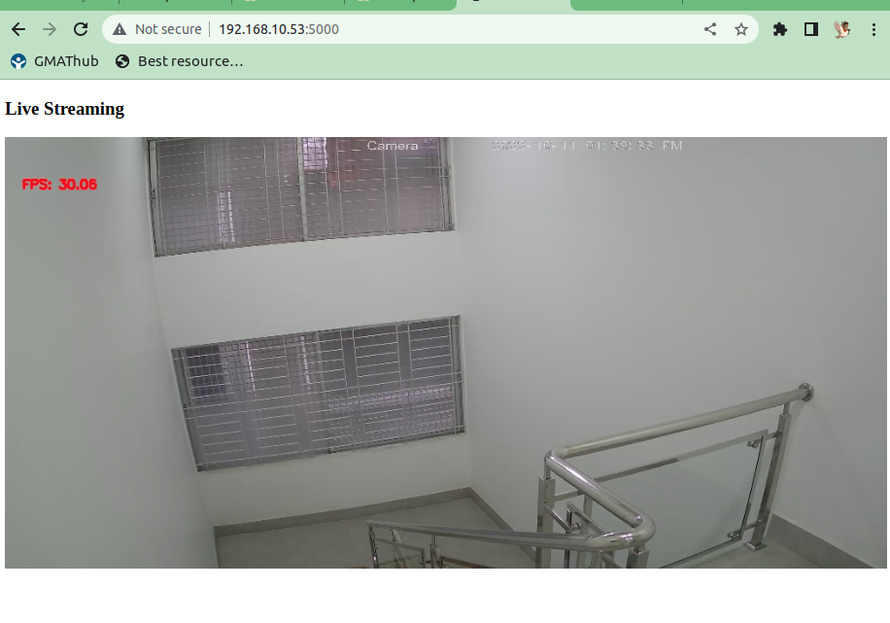

Figure 25: Office camera for face recognition

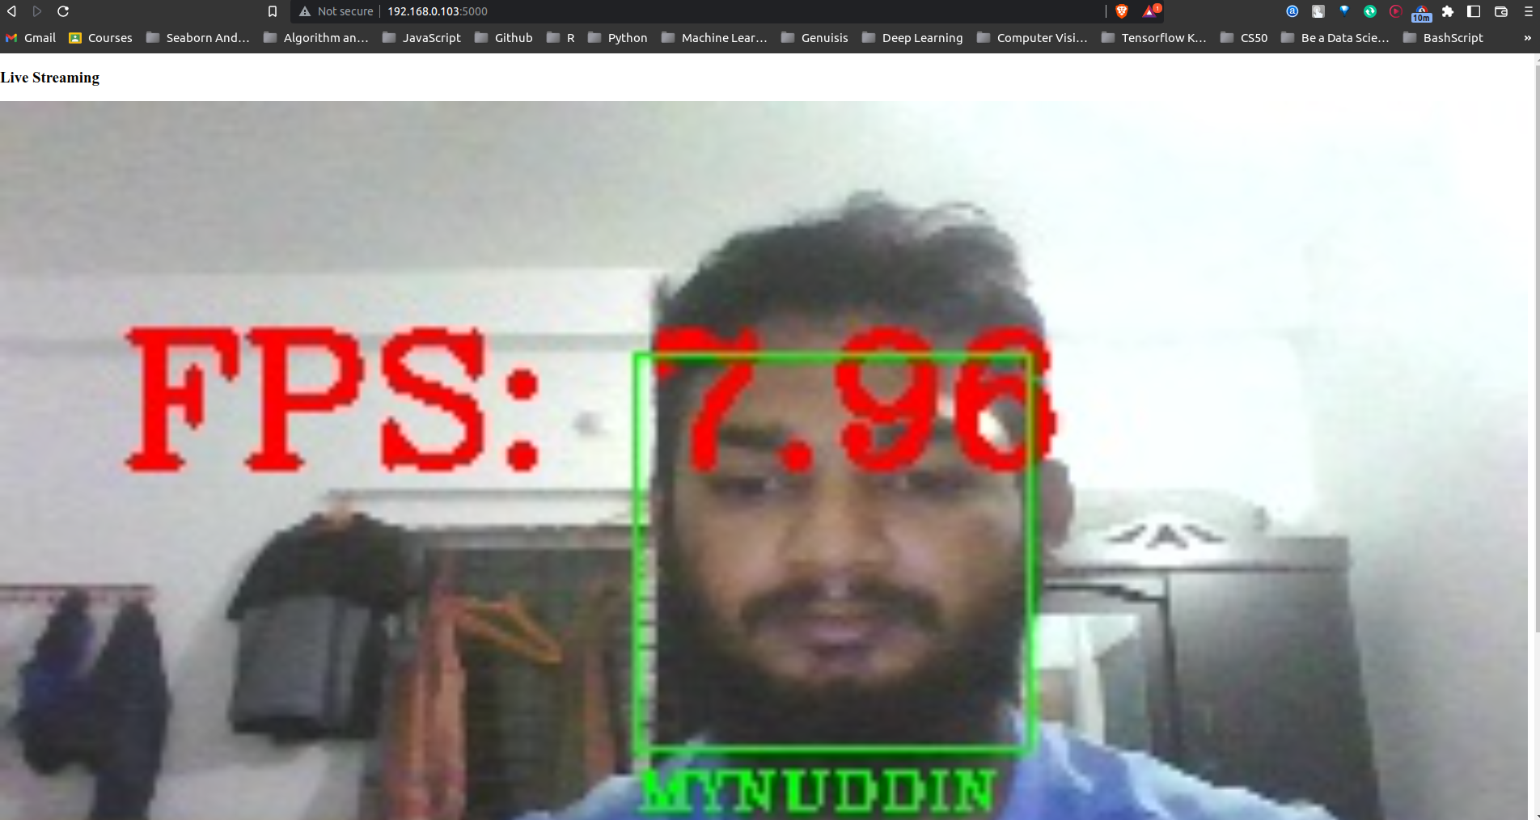

Figure 26: Face recognition for single face

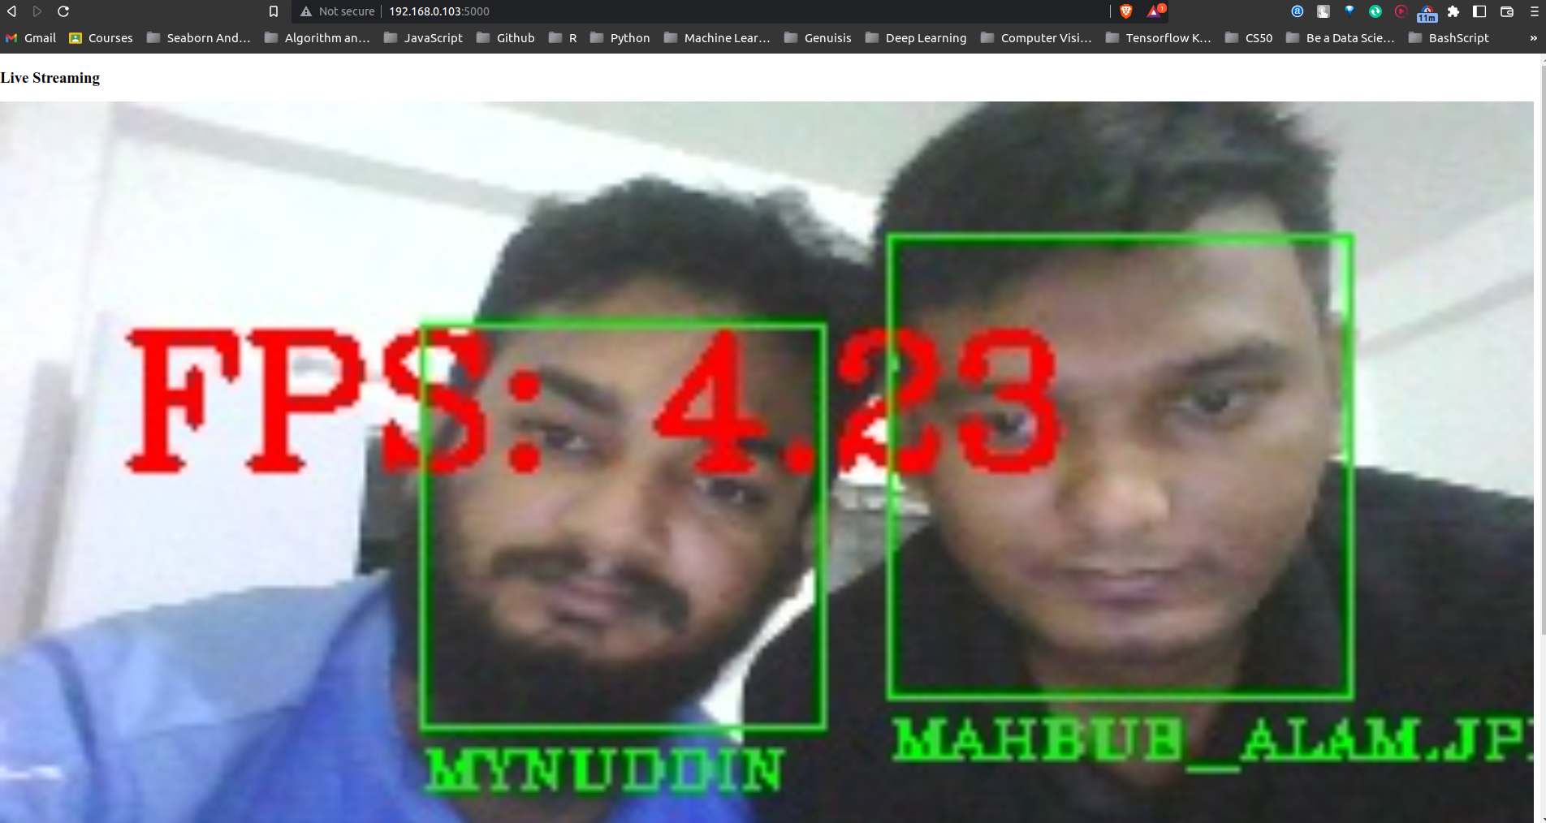

Figure 27: Face recognition for multi-face

As far as I complete every task given by my team leader, I also completed this task on time.

#### **3.5.1.2 Tools and Technology I used**

* Python
* Dlib
* Mediapipe
* Face recognition
* Flask
* VideoStream
* CV2
* Visual Studio Code

Last few days of my internship team leader introduced to me Kaldi ASR (Automated Speech Recognition) for speech to text and Coqui TTS for text to speech.

**3.7. Technical or skill-based lacking and challenges**

* Working with Bangla dataset
* OpenCV
* Linear Algebra
* Neural Network
* Statistic
* Probability
* Calculus

# **Chapter 4: Self Assessment**

**4.1. Self Assessment Form**

**Self Assessment Form**

|  |  |  |  |  |
| --- | --- | --- | --- | --- |
| **Company Name:** | **Genuity Systems Ltd.** | | | |
|  |  | | | |
| **Student Name:** | **Md Mynuddin** | **Student ID:** | **ASH1825007M** |  |

**A. Please select the column that best describes your performance during your internship:**

|  |  |  |  |  |  |  |
| --- | --- | --- | --- | --- | --- | --- |
| **Criteria** | **Outstanding**  **(5)** | **Very Good**  **(4)** | **Average**  **(3)** | **Needs Improvement**  **(2)** | **Poor**  **(1)** | **Sub-Total** |
| **1. Punctuality**  Attends work regularly and on time | ✓ |  |  |  |  | **5** |
| **2. Ability to Solve Problems**  Skill and Duration to resolve issues |  |  | ✓ |  |  | **3** |
| **3. Accuracy of Work**  To be accurate and precise at work |  | ✓ |  |  |  | **4** |
| **4. Creativity**  How much ingenuity you have shown in work |  | ✓ |  |  |  | **4** |
| **5. Dedication**  Produces the expected volume of work in scheduled time | ✓ |  |  |  |  | **5** |
| **6. Professionalism**  Conduct, behavior and attitude at work or business environment |  | ✓ |  |  |  | **4** |
| **7. Team Work**  Cope-up ability with team along with work distribution and helplines with others | ✓ |  |  |  |  | **5** |
| **8. Growth of New Technology**  How frequent and adaptive in learning new tactics and technologies | ✓ |  |  |  |  | **5** |
| **9. Interpersonal Communication**  Maintains effective two-way communication with staff, peers and supervisor | ✓ |  |  |  |  | **5** |
| **10. Leadership Skill**  Takes initiative on project assignments and offers effective solutions for improving operations |  |  |  | ✓ |  | **3** |
| **TOTAL**  **(out of 50)** | | | | | | **43** |

**B. What are the weakness you have identified during Internship period?**

During my internship at Genuity Systems Ltd, I have identified a few areas where I believe I can improve to enhance my overall performance and professional development.

**Time Management:** While I regularly arrived at work on time, I occasionally had trouble managing my time effectively, especially when I was working on many things at once. I want to use improved time management techniques, such as work prioritization, realistic deadlines, and the use of productivity tools, to solve this shortcoming.

**Professional Communication:** Although I received great marks for my interpersonal communication abilities, I am aware that I still need to improve how I convey myself professionally in formal contexts. To ensure clarity and efficacy, I want to concentrate on condensing my thoughts and tailoring my speech to diverse audiences.

**Leadership Skills:** Even though I actively engaged in team projects and showed that I had great teamwork abilities, I admit that I could do more in the leadership department. I want to look for chances to assume additional leadership duties, take on mentoring obligations, and take leadership-development seminars or courses in order to improve this shortcoming.

**Problem-Solving:** Although my problem-solving skills were rated as "average," I am motivated to improve upon them. To improve my ability to deal with complicated problems, I want to actively engage in difficult tasks, look for mentor criticism, and study different problem-solving strategies.

I'm convinced that by recognizing these flaws and proactively working to fix them, I can continue to develop both personally and professionally and contribute more successfully to future projects.

**C. What are your suggestions for improving BSSE program to align with Industry.**

Unquestionably, the BSSE degree course offers a solid foundation in software engineering ideas and principles. However, based on my experience working as an intern at Genuity Systems Ltd., I also provide some additional recommendations for students that more closely match the constantly changing industry:

**Participation in Hackathons:** Encouraging students to take part in hackathons may provide them vital experience coming up with creative ideas while under time pressure. These activities encourage multidisciplinary cooperation, creativity, and teamwork, all of which are crucial in the fast-paced business environment.

**Problem Solving (Competitive Programming):** It might be quite advantageous to incorporate competitive programming into the curriculum. Hackathons and coding contests push students to hone their algorithmic thinking and problem-solving abilities, preparing them for the problems they may face in the workplace.

**Encourage Research and Innovation:** While the current curriculum covers important subjects, it would be beneficial to include chances for students to work on research and innovation initiatives. Within the academic setting, encouraging students to investigate cutting-edge technology and business concerns helps foster an innovative culture.

**Continuous Feedback Mechanism:** It might be quite helpful to implement a feedback mechanism that enables students to express their opinions on the program's advantages and shortcomings. Faculty and administrators can customize the curriculum to match students' changing requirements and market trends by conducting regular surveys or focus groups.

**Industry Networking and Exposure:** Through recurring seminars, workshops, and guest lectures, the program might fortify relationships with businesses and industry experts. Students would get insightful knowledge about actual situations, possible career opportunities, and cultivate contacts that might result in internships or job placements from this experience.

**4.2. Why am I evaluating myself with this number?**

|  |  |  |
| --- | --- | --- |
| **Criteria** | **Rating / Mark** | **Reason** |
| 1. Punctuality | Outstanding (5) | Throughout my internship, I consistently attended work regularly and always arrived on time. My punctuality was crucial in meeting project deadlines and ensuring smooth workflow. |
| 2. Ability to Solve Problems | Average (3) | While I made efforts to resolve issues during my internship, I encountered some challenges that required additional time and support. I believe my problem-solving skills improved over time, but there is still room for further development. |
| 3. Accuracy of Work | Very Good (4) | I took great care to be accurate and precise in my work during the internship. My attention to detail and thoroughness allowed me to produce high-quality outputs and contribute effectively to the projects. |
| 4. Creativity | Very Good (4) | I actively demonstrated ingenuity in my work by approaching tasks with creative solutions. My ability to think outside the box and propose innovative ideas contributed positively to project outcomes. |
| 5. Dedication | Outstanding (5) | Throughout the internship, I consistently demonstrated dedication to my work. I willingly put in extra effort and hours when needed to ensure that project goals were met efficiently and effectively. |
| 6. Professionalism | Average (3) | My conduct and behavior at work were generally professional. However, there were a few instances where I could have improved in certain aspects, such as communication style and adapting to formal environments. |
| 7. Team Work | Outstanding (5) | I excelled in collaborating with the team during my internship. I actively contributed to group projects, supported my colleagues, and effectively handled work distribution and coordination. |
| 8. Growth of New Technology | Outstanding (5) | I demonstrated a high level of adaptability in learning and utilizing new technologies during my internship. I actively sought opportunities to expand my skillset and keep up with the latest industry trends. |
| 9. Interpersonal Communication | Outstanding (5) | My interpersonal communication skills were a strong asset during the internship. I maintained effective two-way communication with colleagues, peers, and supervisors, which fostered a positive work environment. |
| 10. Leadership Skill | Needs Improvement (2) | While I attempted to take initiative and offer solutions, I recognize that my leadership skills need further development. I aim to enhance my ability to lead and take charge of project assignments in the future. |

## **4.3. Overall Progress**

The six months internship period, has given me a lot of experience and knowledge. With these experiences, I can build my career more successfully in the future. Working on a Machine Learning team has made my analytical mind stronger. Now I am pretty much sure that, I have the capability to work with real-life problems. Involvement in these projects also taught me how to manage everything easily, how to maintain tasks timeline and schedules, and how to develop a system. The journey at Genuity Systems ltd. made me more hardworking, passionate, punctual, responsible, and confident.

# **Chapter 5: Conclusion**

I learned valuable information about the software industry, its culture, working conditions, and all about software development thanks to the internship program. Participating in daily and weekly team meetings with the team leader and other team members and talking about the challenges of the projects gave me the confidence to cultivate a never-give-up mentality. In addition, it motivated me to work hard, be accountable, and self-assured while teaching me about the software life cycle used in the software industry. The thing I want and cherish the most is inspiration. They constantly gave me the motivation and tools I needed to learn new skills and adapt to them. They also gave me advice on what to study and how to approach the learning process.

My ability to work in a team and my respect for the opinions and ideas of my teammates have both risen as a result of the internship program. I was able to discover and resolve a number of problems that would have been hard to tackle without the assistance of team talks and brainstorming sessions.

I would want to express my gratitude to IIT, NSTU for giving me the chance to learn more about the professional field's competitive climate. In terms of planning, designing, coding, and deployment, it has unquestionably improved my software development skills. I am now eager to take on the forthcoming problems that the world will present.

# **Chapter 6: References**

[1] <https://www.genuitysystems.com/index.php> “Genuity Systems Ltd.” [Acees 23 October 2022]

[2] <https://www.facebook.com/groups/1645869302384991> “Genuity Systems Ltd. Facebook Group” [Acees 23 October 2022]

[3] <https://github.com/Mynuddin-dev?tab=repositories> “Github” [Acees 23 October 2022]

[4] <https://docs.opencv.org/4.x/d6/d00/tutorial_py_root.html> “OpenCV Doc” [Acees 23 October 2022]

[5] <https://github.com/Mynuddin-dev/Bash-Script> “Bash Script Github Repo” [Acees 23 October 2022]